Appendix 7
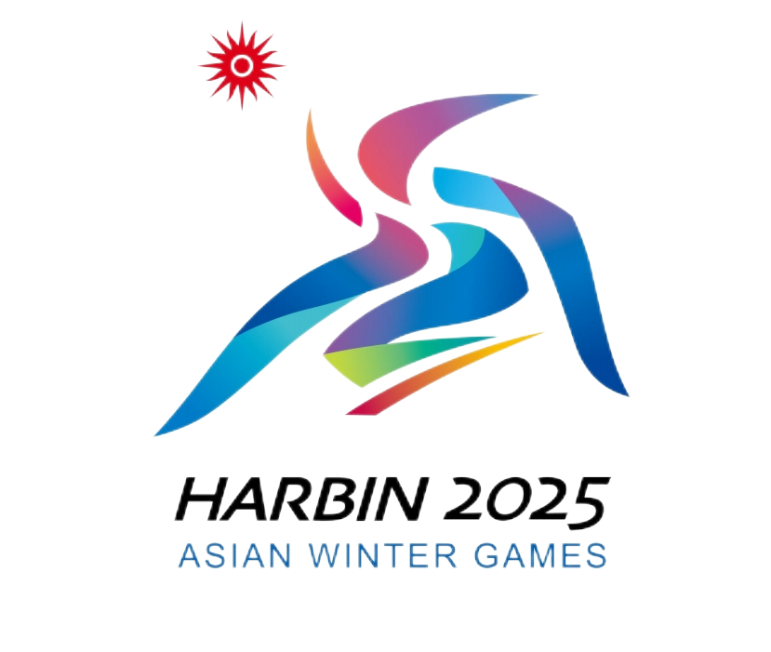
Letter of Proof for Self-used Goods for Harbin 2025
2025年第九届亚洲冬季运动会自用物资担保函

Goods Description  商品名称 | Self-used goods for Harbin 2025  2025年第九届亚洲冬季运动会自用物资 |  |  | Country/Region of Departure  启运国
Goods Owner  商品所有人 |  |  |  | Total Value (Currency)  总价（币制） |  | Means of Transport  运输工具
Flight No.航班号  Bill of Lading (Waybill)  提（运）单号 |  |  |  | Number of Piece(s)  件数 |  | Weight (Gross)重量（毛重）
Availability of Documents  提供文件情况 | List of Imported Goods for Self-use  自用物资进境清单 |  |  | Entry/Exit Port  进/出口岸 |  | Entry/Exit Date  进/出日期
Availability of Documents  提供文件情况 | Declaration of Self-use自用证明 |  |  | Quarantine Approval  是否需要检疫审批 |  | Needed需要 | Not Needed不需要
Availability of Documents  提供文件情况 | Declaration of Sanitary Responsibility  自用物资安全卫生责任自负声明
Availability of Documents  提供文件情况 | Certificate of Origin  产地证明
Availability of Documents  提供文件情况 | Quarantine Certificate检疫证书
Remarks:
备注
To Customs致：海关
Certification:证明事项：
The 9th Asian Winter Games Harbin 2025 Organising Committee certifies that the goods are used for Harbin 2025 and only for the Client Groups of Harbin 2025.2025年第九届亚洲冬季运动会组委会证明此票货物为2025年第九届亚洲冬季运动会自用物资，并仅为参加赛事客户群使用。
Declarant (Signature and Seal)申报单位（签章）
Certified by (Official Stamp)  证明人（公章） |  |  |  |  | Contact Person:  联系人：
Tel:电话：
Date: dd/mm/yyyy日期：日/月/年
Customs Remarks:
海关批注：
Certified by: 证明人： No.:编号：
(Original: kept by competent Customs; Copy 1: kept by the Customs at the place of entry; Copy 2: kept by the owner or broker.)
（正本：主管海关留存；副本1：进境地海关留存；副本2：所有人或代理人留存。

