Annex 6
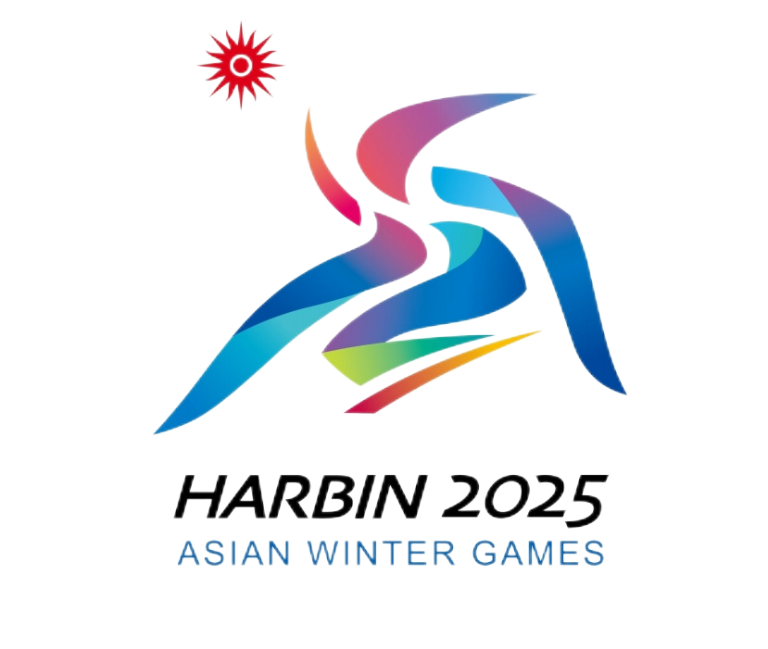
Declaration of Sanitary Responsibility of Self-used Goods for Harbin 2025
2025年第九届亚洲冬季运动会代表团自用物资安全卫生责任自负声明

Delegation代表团: （Client Group Name客户群名称）
Flight No.航班号:
My delegation hereby declares that the goods on the list comply with the relevant safety and hygiene standards. Should any safety or hygiene issues arise during their use of the goods listed, my delegation will assume full responsibility for all associated consequences.本代表团保证附表所列物资符合安全卫生标准，如本团体在使用期间出现任何安全卫生问题，本团体将自行承担一切相关责任。

Signatory签署人:______________________
Date日期: dd/mm/yyyy(日/月/年)
(Original: kept by competent Customs; Copy 1: kept by Customs at the place of entry; Copy 2: kept by the owner or broker.)
（正本：主管海关留存；副本1：进境地海关留存；副本2：所有人或代理人留存。）

