Appendix 5
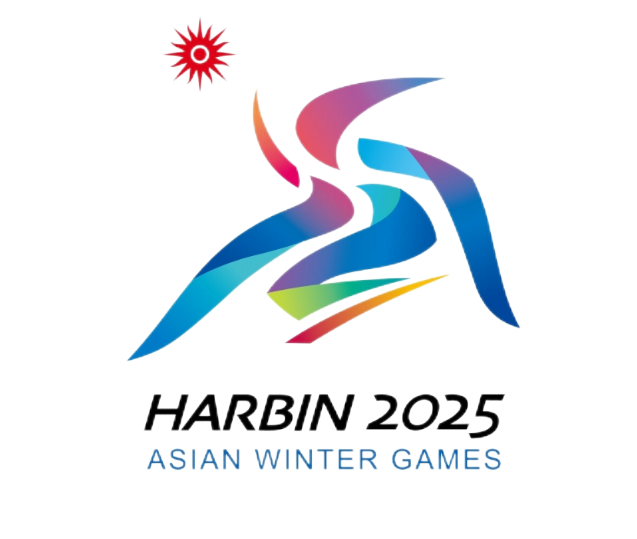
Declaration of Self-use of Imported Goods for Harbin 2025
2025年第九届亚洲冬季运动会代表团物资自用证明

Delegation代表团: （Client Group Name客户群名称）
Flight No.航班号:
My delegation hereby declares that the goods on the list are imported strictly for the purpose of self-use by the delegation and not for any other purposes. Any remaining goods will either be re-exported or destroyed under the supervision of China Customs. In case of any violation, the delegation accepts full responsibility for all associated consequences.本代表团保证附表所列物资全部为团体自用，保证不在团体之外使用。如有剩余，保证退运或交中方销毁。如有违反，本团体将承担一切相关责任。

Signatory签署人:________________________
Date日期: dd/mm/yyyy(日/月/年)
(Original: kept by competent Customs; Copy 1: kept by the Customs at the place of entry; Copy 2: kept by the owner or broker.)
（正本：主管海关留存；副本1：进境地海关留存；副本2：所有人或代理人留存。）

