Annex 4
List of Imported Goods for Self-use for Harbin 2025
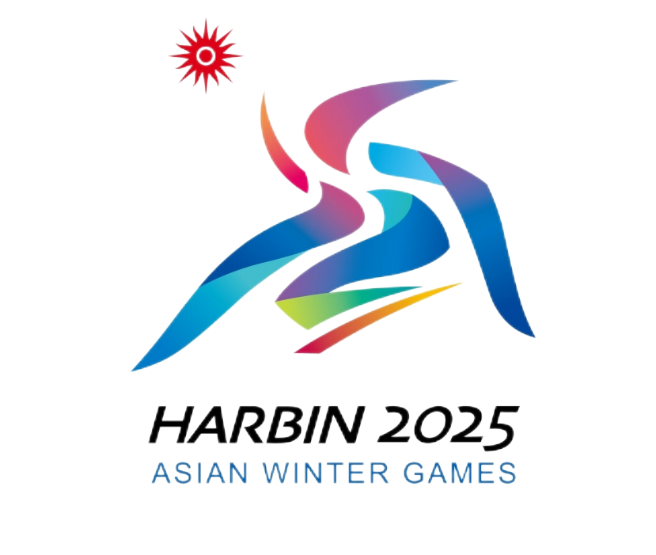
2025年第九届亚洲冬季运动会代表团进境自用物资清单

Flight No.航班号: List of Imported Goods for Self-use No.自用物资清单编号:
Name  品名 | Quantity  数量 | Main Contents  主要成分 | Weight  重量 | Origin  产地 | HS Code  HS编码 | Purpose  用途 | Remarks  备注
Representative Signature:同行代表人签字:
Representative Passport No.:同行代表人护照号:
(Original: kept by competent Customs; Copy 1: kept by the Customs at the place of entry; Copy 2: kept by the owner or broker.)
（正本：主管海关留存；副本1：进境地海关留存；副本2：所有人或代理人留存。）

