China Customs Enforcement of Intellectual Property Rights (IPR) in 2007

General Administration of Customs of the People’s Republic of China (GACC)

Contents

Foreword
1. Achievements of China Customs IPR Enforcement in 2007
(1) Highlighting and Strengthening of IPR Enforcement Functions of China Customs
(2) Optimization of the Legal System for China Customs IPR Enforcement
(3) Enhancing of the Law Enforcement Level of China Customs IPR Protection
(4) Comprehensive Strengthening of the Cooperation in Customs IPR Enforcement
(5) Rapid Increasing of Infringing Goods Seized in the Import and Export Infringing Goods Cases
(6) Recognition of all Circles of the Society on the Achievements of China Customs IPR Enforcement
2. Challenges Currently Faced by China Customs in IPR Enforcement
(1) More Pressures on China Customs IPR Enforcement Due to Rapid Increase of Import & Export Volumes
(2) More Diversified Infringing Methods Adopted by Lawbreakers
(3) Ineffective Cooperation Provided by Some IPR Holders to the Law Enforcement of China Customs
(4) Weak Awareness of IPR Protection of Import and Export Enterprises
3. Major Tasks for China Customs IPR Enforcement in 2008
(1) Adopt the Risk Analysis Method to Seize Infringing Goods
(2) Continue to Improve the Law Enforcement Basis for China Customs IPR Protection
(3) Strengthen China Customs IPR Enforcement in Major Areas and Major Sectors
(4) Enhance the Protection to the Independent IPRs of Domestic Enterprises
(5) Strengthen the Trainings for On-site Customs Inspectors
(6) Actively Conduct the Publicity for China Customs IPR Enforcement
Conclusion

Foreword

The year 2007 witnessed the rapid development of China Customs enforcement of intellectual property rights (IPR). The customs houses at different levels across China thoroughly implemented the Scientific Outlook on Development and carried out the major decisions of the Central Committee of the Communist Party of China and the State Council for building an innovative country. China Customs comprehensively strengthened their efforts for the IPR enforcement and strived to play a more important role in the IPR protection system of China. In this way, the China Customs IPR enforcement has become an effective means to stimulate the transformation of economic development mode and safeguard the implementation of different macroeconomic regulation measures.

1. Achievements of China Customs IPR Enforcement in 2007

(1) Highlighting and Strengthening of IPR Enforcement Functions of China Customs
In order to meet the new requirements on China Customs IPR enforcement imposed by the development of domestic and international economic and political situations, the Board of the General Administration of Customs held a special meeting in May 2007 and made an in-depth research on a series of major problems concerning the further improvement of China Customs IPR enforcement in the new situations. In November 2007, the Board of the General Administration of Customs formulated and issued the Opinions on Strengthening China Customs IPR Enforcement, which commented that China Customs IPR enforcement is a major responsibility of China Customs in the new situations and is the representation that China Customs implement their non-traditional functions, and made a comprehensive deployment of China Customs IPR enforcement work in the current and future periods. Afterwards, the General Administration of Customs held the National Customs IPR Enforcement Work Meeting, which summarized the achievements and experiences of China Customs IPR enforcement in the last ten years, analyzed the current situations and tasks, and imposed specific requirements on the Customs work in the future. As the highest decision-making organ in the National Customs System, the General Administration of Customs attached high importance to China Customs IPR enforcement and adopted a series of measures to strengthen the work. This attitude of the General Administration of Customs was unprecedented in the development history of China Customs and was rare for the customs of other countries in the world. With the correct leadership of the Board of the General Administration of Customs, the customs houses across China further improved their understanding of the significance and emergency of strengthening IPR protection, and according to the unified deployment of the General Administration of Customs, adopted proactive measures to strengthen China Customs IPR enforcement, severely cracked down on the IPR infringing activities of import and export goods, continued to strengthen the efforts in China Customs IPR enforcement, and inputted more resources to China Customs IPR enforcement, so as to ensure that the basic function of China Customs IPR enforcement is effectively fulfilled.

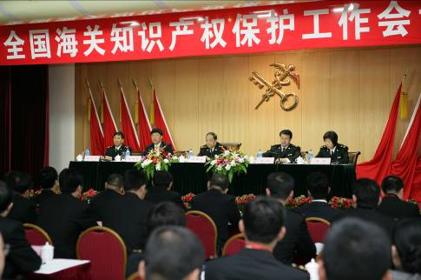
The General Administration of Customs held the National Customs IPR Enforcement Work Meeting in Kunming City in November 2007

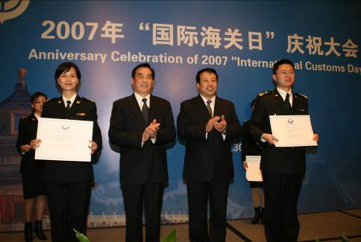
The leaders of the General Administration of Customs presented the award of Excellent Customs Inspector (IPR enforcement) to China Customs Officers ranked by the World Customs Organization on the International Customs Day in 2007

(2) Optimization of the Legal System for China Customs IPR Enforcement
1) Release an announcement on the auction of seized infringing goods according to the law
To effectively standardize the disposal and auction of the seized infringing goods, increase the law enforcement transparency of the Customs, and safeguard the IPR holders' right to information, the General Administration of Customs formulated and issued the Announcement on the Auction of Infringing Goods Seized by Customs According to the Law in April 2007, which provides that when the Customs make an auction on the seized infringing goods, the Customs shall remove all the infringing characteristics of the goods and the packages, including the characteristics of infringing the trademarks, copyrights, patent rights and other IPRs. For the goods whose infringing characteristics cannot be totally removed, the goods shall be destroyed and should not be auctioned. In addition, before the auction of infringing goods, the Customs shall solicit the opinions of the relevant IPR holders.

2) Regard the import and export infringing records as one of the consideration factors for classified management of enterprises according to the principle of "compliance and facilitation, violation and punishment"
On January 4, 2008, the General Administration of Customs published the new Measures of the Customs of the People's Republic of China on the Classified Management of Enterprises, which for the first time regarded the IPR infringing condition as one of the consideration factors for implementing the classified management of enterprises. The enterprises which meet the 11 conditions (including have not been punished by the Customs due to exporting or importing IPR infringing goods for a year) were classified as the Class-A import and export goods consignees and consignors. The enterprises which meet the 10 conditions (including have been acting as a customs declaration agent for a year whose goods have not been seized by the Customs due to IPR infringement) were classified as the Class-A customs brokers. The aforesaid enterprises enjoyed the corresponding treatment such as convenience in customs clearance, so that their goods import and export efficiency was improved. For the Class-C enterprises (the import and export goods consignees and consignors that have been punished by the Customs twice during a year for importing or exporting IPR infringing goods, or the customs brokers whose goods have been seized by the Customs for three times during a year due to IPR infringement) and Class-D enterprises (the import and export goods consignees and consignors that have been punished by the Customs for three times during a year for importing or exporting IPR infringing goods, or the customs brokers whose goods have been seized by the Customs for four times during a year due to IPR infringement), the Customs implemented stricter supervision on their import or export goods, so as to prevent these enterprises from committing infringement again.

(3) Enhancing of the Law Enforcement Level of China Customs IPR Protection

1) Enhance the trainings and improve the ability of Customs inspectors to supervise infringing goods
At present, the infringing goods supervision implemented by China Customs is mainly in the form of random inspection on import and export goods. In 2007, about 90% of the infringing goods are seized by the Customs during random inspection (see Table 1). The improvement of the Customs' supervision on infringing goods is firstly represented by the improvement of the Customs inspectors' ability to seize infringing goods. As the major law enforcement means currently adopted by the Customs of all countries, goods inspection plays an important role in the seizure and detainment of import and export infringing goods. China Customs attached much importance to the ability of on-site Customs inspectors to seize infringing goods, and frequently invited the IPR holders to provide specialized trainings about infringing goods discrimination for the on-site Customs inspectors.

Table 1 Statistics on the means adopted by China Customs to seize infringing goods in 2007

Means to Seize Infringing Goods | Batch | Percentage | Quantity of Infringing Goods | Value of Goods
Random inspection | 6,753 | 90% | 82,799,781 | 188,800,755
Risk analysis | 604 | 8% | 176,741,834 | 125,544,489
Sheets review | 67 | 1% | 73,477,237 | 121,526,460
Crime reporting | 20 | Not more than 1% | 463,479 | 2,825,886
Intelligence reporting | 1 | Not more than 1% | 135 | 36,570
Others | 22 | Not more than 1% | 15,783 | 121,406
Unit of batch: batch (a batch refers to an application to the Customs);
Unit of infringing goods quantity: PCS/Pair; Unit of goods value: RMB

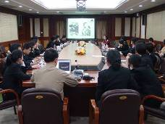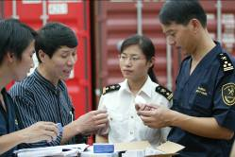
The Customs invited IPR holders to provide trainings about infringing goods discrimination to the Customs inspectors

2) Adopt risk management techniques to improve the rate of seizing infringing goods
To meet the requirements of rapidly increasing workload of Customs inspection, the customs houses across China adopted a new philosophy of law enforcement and introduced advanced supervision techniques like risk analysis into the China Customs IPR enforcement. China Customs attached more importance to the collection and analysis of infringing information and conducted law enforcement activities with clear goals, so as to realize the intelligent supervision on infringing goods. In 2007, China Customs adopted the risk analysis technique to seize 604 consignments of infringing goods, accounting for 8% of the total quantity of infringing goods seized in the year.



Shanghai Customs adopted the risk analysis technique to supervise infringing goods

3) Conduct special campaigns of law enforcement to enhance the crack down on import and export infringing activities
To effectively crack down on the illegal activities for the import and export of infringing goods, the General Administration of Customs conducted the "Special Campaign on the Crackdown of IPR Infringing Activities through the Postal Express Means" and the "Special Campaign of Customs IPR Enforcement in Yangtze River Delta Area" in 2006, and at the end of September 2007, conducted the "Dragon Boat Operation" for curbing the export of infringing goods through European and American air routes during a 6-month period. For the first three months of the "Dragon Boat Operation" (October 1 to December 31, 2007), the ports customs across China detained a total of 2,411 consignments of infringing goods for export, or 77,540,745 PCS of infringing goods, with a total value of RMB 94,804,815, which increased by 226%, 251% and 105% respectively as compared with those figures in the same period of 2006 (see Table 2).

Table 2 China Customs IPR enforcement achievements in the first three months of the "Dragon Boat Operation"
Year  (4th Quarter) | Batch | Increase | Quantity of Infringing Goods | Increase | Value of Goods | Increase
2006 | 739 |  | 22,106,250 |  | 46,221,371
2007 | 2,411 | +226% | 77,540,745 | +226% | 94,804,815 | +105%
Unit of batch: batch; Unit of infringing goods quantity: PCS/Pair; Unit of goods value: RMB

(4) Comprehensive Strengthening of the Cooperation in Customs IPR Enforcement

1) Enhance the cooperation with domestic law enforcement authorities
As the supervision authority for export and import, China Customs perform the IPR enforcement only in certain areas like ports. However, many lawbreakers involved in infringing activities have established a complete infringement network including the sectors of manufacturing, transportation, sales, and import & export. Under this circumstance, China Customs enhanced the cooperation with the administration for industry and commerce, IPR management authority, and public security authority in the fields such as infringing case investigation, infringing goods identification, law enforcement information sharing, etc., and thus obtained good achievements.

In July 2007, Huangpu Customs continuously received the reporting from Unilever that a batch of counterfeit toothpastes of Unilever CLOSE UP brand in containers will exit via Huangpu Port to other countries. Huangpu Customs found out the reported two containers by camera monitoring. In the subsequent one month, however, nobody applied for customs declaration for the two containers. In accordance with the law, the Customs has the authority to inspect or detain any goods only after the goods have been applied for customs declaration. The reason why the lawbreakers have not applied for customs declaration for a long time may be that they were aware that the Customs were investigating on them. In order to avoid the infringing goods being transported to other places, Huangpu Customs reported the relevant information to the administration for industry and commerce which have the authority to detain the goods. Then the administration for industry and commerce and the customs immediately conducted a joint inspection on the two containers and seized 298,730 pieces of counterfeit toothpastes with a total value of nearly RMB 1 million. The cooperation between the customs and the administration for industry and commerce successfully cracked down on the lawbreakers who intended to evade legal sanction through delay of customs declaration, and provided a typical model for the crackdown of IPR infringement through the cooperation between different law enforcement authorities.

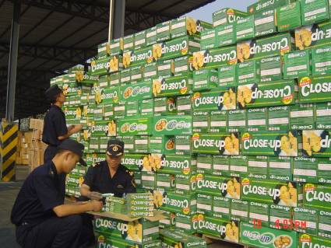
Huangpu Customs officers were counting the seized counterfeit toothpastes

In June 2007, the Ministry of Public Security of China informed the General Administration of Customs that a company intended to export a batch of counterfeit sports shoes from Ningbo port to the United States. Then the General Administration of Customs immediately required the Ningbo Customs to start supervision. On June 27, Ningbo Customs found out four suspicious containers and seized 39,360 pairs of counterfeit NIKE and JORDAN sports shoes.
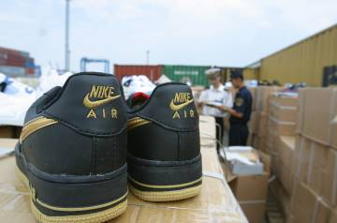
Ningbo Customs seized counterfeit sports shoes

2) Deepen the cooperation with the Customs of other countries and regions
As of the year 2007, the Chinese government has signed bilateral customs cooperation agreements with more than 30 countries and regions in the world. Many of the agreements contain the provisions on the cooperation of IPR enforcement. China Customs continued to deepen the cooperation with the customs of the USA, European Union, Japan and Hong Kong region of China in the aspects of IPR enforcement information exchange, law enforcement trainings, and the exchanges of law enforcement experiences and personnel. In April 2007, the meeting of Ministers of Customs of China, Japan and South Korea decided to establish the Customs IPR Enforcement Work Group of China, Japan and South Korea, which held its first meeting in October 2007 and formulated the Customs IPR Enforcement Action Plan of China, Japan and South Korea. In May 2007, during the period of the Second China-US Strategic Economic Dialogue, the Customs of China and the USA signed the Memorandum on the Strengthening of Border IPR Enforcement Cooperation in Washington.

(5) Rapid Increasing of Infringing Goods Seized in the Import and Export Infringing Goods Cases

In 2007, China Customs implemented the IPR enforcement measures for 8,508 times, detained 7,467 consignments of infringing goods, seized 333,498,249 PCS of infringing goods, with a total value of RMB 438,855,566. As compared with 2006, the aforesaid figures increased by 41%, 33%, 61 % and 55 % respectively (see Table 3 and 4).

Table 3 Statistics on the IPR enforcement measures in 2007

Year | IPR Enforcement Measures | Year-on-year Increase | Consignments of Detained Infringing Goods | Year-on-year Increase
2006 | 6033 |  | 5607
2007 | 8508 | +41% | 7467 | +33%
Unit of adopted IPR enforcement measures: Time; Unit of batch of detained infringing goods: batch

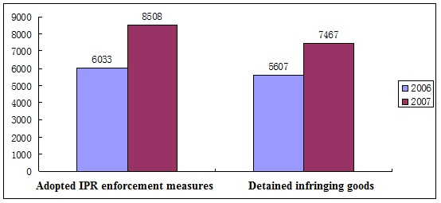

Table 4 Statistics on the infringing goods detained by China Customs in 2007

Year | Quantity of Infringing Goods | Year-on-year Increase | Value of Goods | Year-on-year Increase
2006 | 207,707,354 |  | 283,691,661
2007 | 333,498,249 | +61% | 438,855,566 | +55%
Unit of infringing goods quantity: PCS/Pair; Unit of goods value: RMB

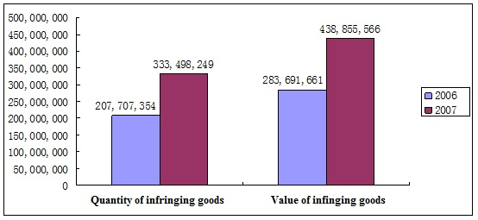
Value of infringing goods

The cases of infringing goods seized by China Customs in 2007 have the following features:
1) Infringing goods are mainly seized in the export sector
In 2007, China Customs seized 557,920 PCS of infringing goods in the import sector and 332,940,329 PCS of infringing goods in the export sector. The quantity of infringing goods seized in the export sector accounted for 99.8% of the total quantity of seized infringing goods, and its value accounted for 99.3% of the total value of seized infringing goods (see Table 5).

Table 5 Statistics on the import and export of infringing goods seized in 2007

 | Quantity of Infringing Goods | Percentage | Value of Goods | Percentage
Import | 557,920 | 0.2% | 3,132,238 | 0.7%
Export | 332,940,329 | 99.8% | 435,723,328 | 99.3%
Unit of infringing goods: PCS; Unit of goods value: RMB

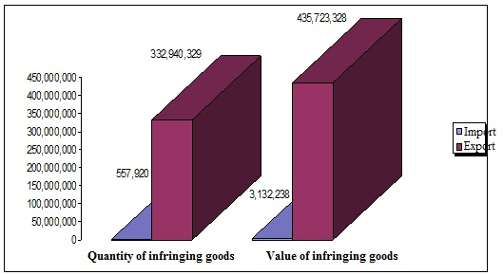

2) Infringing goods are mainly transported by shipping
Among the infringing goods seized by China Customs, most of the goods are seized by the Customs during the supervision on export and import of the infringing goods transported by shipping on rivers and oceans. The quantity of seized goods transported by shipping accounted for 97% of the total quantity of seized infringing goods, and its value accounted for 86% of the total value of seized infringing goods in 2007 (see Table 6). It is worth noting that it was more frequent that the infringing goods were exported or imported through postal and express means. The times of seizing infringing goods by the Customs in postal and express means accounted for 78% of the total times of seizing infringing goods (see Table 7).

Table 6 Statistics on the quantity and value of infringing goods transported in different means

Means of Transport | Quantity of Infringing Goods | Percentage | Value of Goods | Percentage
Shipping | 320,787,074 | 97% | 377,937,632 | 86%
Road | 7,029,791 | 2% | 4,922,733 | 1%
Express | 3,462,057 | 1% | 9,960,701 | 2%
Postal | 1,601,343 | Not more than 1% | 11,060,019 | 3%
Air | 306,413 | Not more than 1% | 24,852,386 | 6%
Others | 174,380 | Not more than 1% | 1,371,722 | Not more than 1%
Railway | 137,191 | Not more than 1% | 8,750,372 | 2%
Unit of infringing goods: PCS; Unit of goods value: RMB

Infringing Goods
96%
2%
1%
Shipping
Road
Express
Postal
Air
Others
Railway

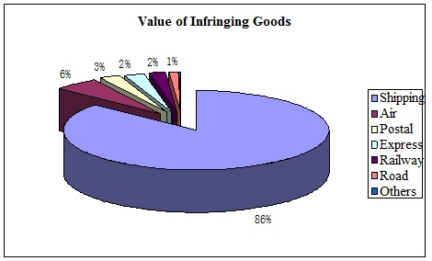

Table 7 Statistics on the consignments of detained infringing goods transported in different means

Means of Transport | Consignments of Detained Goods | Percentage
Express | 3,587 | 48%
Postal | 2,228 | 30%
Shipping | 1,045 | 14%
Road | 201 | 3%
Air | 160 | 2%
Others | 136 | 2%
Railway | 110 | 1%
Unit of detained goods: batch

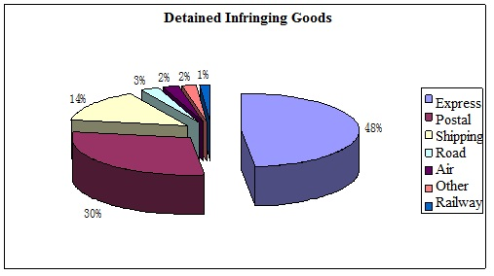

3) Infringing goods are mainly transported through coastal ports for export and import
The costal ports of China are the main export and import ports for infringing goods. In 2007, ten customs houses, namely, Shenzhen Customs, Shanghai Customs, Ningbo Customs, Hangzhou Customs, Huangpu Customs, Guangzhou Customs, Qingdao Customs, Fuzhou Customs, Xiamen Customs and Tianjin Customs, seized a total of 332,436,959 PCS of infringing goods, accounting for 99.7% of the total quantity of seized infringing goods. Its value reached RMB 370,586,512, accounting for 84% of the total value of seized infringing goods (see Table 8).

Table 8 Ten customs houses which seized more infringing goods in 2007

 | Name of Customs District | Quantity of Infringing Goods | Percentage | Value of Goods | Percentage
1 | Shenzhen Customs | 195,726,666 | 59% | 42,568,891 | 10%
2 | Shanghai Customs | 109,087,765 | 33% | 156,669,289 | 36%
3 | Ningbo Customs | 9,161,716 | 3% | 31,000,483 | 7%
4 | Hangzhou Customs | 5,859,144 | 2% | 9,112,834 | 2%
5 | Huangpu Customs | 3,895,245 | 1% | 4,492,637 | 1%
6 | Guangzhou Customs | 2,693,397 | 1% | 28,288,654 | 6%
7 | Qingdao Customs | 2,496,008 | 1% | 72,479,034 | 17%
8 | Fuzhou Customs | 1,539,046 | 1% | 10,800,939 | 2%
9 | Xiamen Customs | 1,203,712 | Not more than 1% | 9,215,047 | 2%
10 | Tianjin Customs | 774,260 | Not more than 1% | 5,958,704 | 1%
Unit of infringing goods: PCS; Unit of goods value: RMB

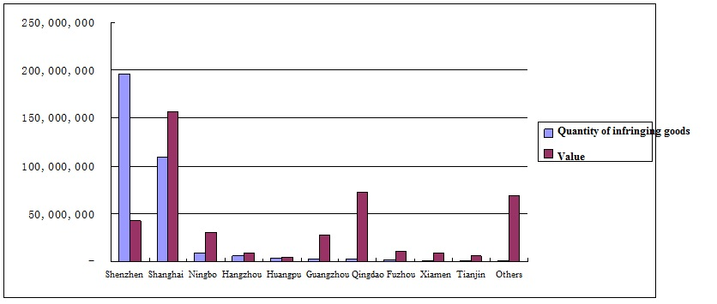

4) Infringing goods are mainly related to the infringement of the exclusive right to use trademarks
In 2007, China Customs seized a total of 329,800,223 PCS of goods that infringed the exclusive right to use trademarks, accounting for 99% of the total quantity of seized infringing goods. Its value reached RMB 425,655,813, accounting for 97% of the total value of seized infringing goods (See Table 9).

Table 9 Statistics on the types of rights relating to the infringing goods seized in 2007

Type of Right | Quantity of Infringing Goods | Percentage | Value of Goods | Percentage
Exclusive Right to Use Trademarks | 329,800,223 | 99% | 425,655,813 | 97%
Patent Right | 3,621,340 | Not more than 1% | 11,782,064 | 2%
Copyright | 36,431 | Not more than 1% | 644,705 | Not more than 1%
Olympic logo | 40,255 | Not more than 1% | 772,984 | Not more than 1%
Unit of infringing goods quantity: PCS; Unit of goods value: RMB
5) The IPRs of multiple countries are being protected by China Customs
In 2007, China Customs implemented the protection on a total of 5,776 items of IPRs. The IPR holders under protection are from 34 countries, regions and international organizations including the USA, the UK, Japan, France, Greece, Germany, the Netherlands, Finland, Thailand, Liechtenstein, Italy, South Korea, Switzerland, Indonesia, Luxemburg, Canada, Sweden, the UAE, India, Spain, Turkey, the British Virgin Islands, the British Cayman Islands, Singapore, South Africa, Denmark, Mongolia, Russia, Austria, China, Hong Kong of China, Taiwan of China, the International Olympic Committee and FIFA.

Among the infringing goods seized by China Customs, the quantity of the goods that infringed the IPRs of enterprises of the USA, the UK, China, Japan, Greece, France, Germany, the Netherlands, Finland and Thailand are relatively great, accounting for 98.2% of the total quantity of seized infringing goods (see Table 10). In terms of goods value, the values of the goods that infringed the IPRs from the USA, China, Japan, Germany, France, the UK, Finland, the Netherlands, Hong Kong of China and Switzerland are relatively great, accounting for 94.5% of the total value of seized infringing goods (see Table 11).
Table 10 Statistics on the countries of the IPR holders (in terms of the quantity of infringing goods)
Country of IPR Holder | Quantity of Infringing Goods | Percentage
USA | 235,559,161 | 70.6％
United Kingdom | 45,789,780 | 13.7％
China | 11,901,071 | 3.6％
Japan | 7,515,015 | 2.3％
France | 9,352,163 | 2.8％
Greece | 9,382,560 | 2.8％
Germany | 2,263,922 | 0.7％
The Netherlands | 4,346,396 | 1.3％
Finland | 679,689 | 0.2％
Thailand | 640,320 | 0.19％
Total | 327,430,077 | 98.2％
Unit of infringing goods quantity: PCS

Table 11 Statistics on the countries of the IPR holders (in terms of the value of infringing goods)
Country of IPR Holder | Value of Infringing Goods | Percentage
USA | 246,775,671 | 56%
China | 44,101,456 | 10%
Japan | 25,629,376 | 6%
Germany | 23,784,235 | 5%
France | 21,190,088 | 5%
United Kingdom | 16,067,277 | 4%
Finland | 15,713,739 | 4%
The Netherlands | 11,553,647 | 3%
Hong Kong of China | 6,549,865 | 1%
Switzerland | 3,401,080 | 1%
Total | 414,766,434 | 94.5%
Unit of infringing goods value: RMB

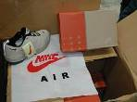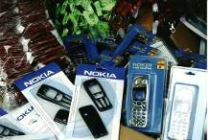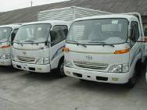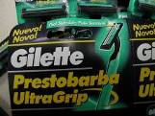
China Customs seized the counterfeit goods of internationally renowned brands

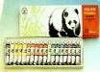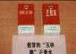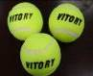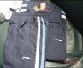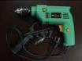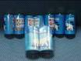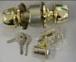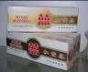
China Customs seized the counterfeit goods of domestically renowned brands

6) Most of the infringing goods are consumer goods
The categories of the infringing goods seized by China Customs are mainly clothes, shoes, bags and cases, cigarettes, etc. Among the seized infringing goods, the batch, value and quantity of counterfeit cigarettes are relatively great (see Table 12).

Table 12 Statistics on the infringing goods

Category of Goods | Batch | Percentage | Total Quantity | Percentage | Value | Percentage
Clothes | 1,271 | 16% | 1,920,959 | 1% | 23,440,416 | 5%
Shoes | 1,156 | 14% | 1,010,588 | Not more than 1% | 27,216,418 | 6%
Hats | 64 | 1% | 518,303 | Not more than 1% | 5,610,478 | 1%
Bags, cases and leather products | 1,445 | 18% | 768,932 | Not more than 1% | 8,975,961 | 2%
Cosmetic and personal care products | 101 | 1% | 4,198,600 | 1% | 14,778,788 | 3%
Other light industrial products | 642 | 8% | 10,297,851 | 3% | 30,156,074 | 7%
Automobiles and motorcycles | 43 | 1% | 313,481 | Not more than 1% | 10,865,940 | 2%
Watches | 185 | 2% | 197,705 | Not more than 1% | 3,587,827 | 1%
Toys and games | 32 | Not more than 1% | 129,518 | Not more than 1% | 3,772,030 | 1%
Communication devices | 369 | 5% | 643,244 | Not more than 1% | 22,670,746 | 5%
Storage media | 458 | 6% | 194,214 | Not more than 1% | 3,753,450 | 1%
Other mechanical and electrical products | 340 | 4% | 8,975,506 | 3% | 23,826,981 | 5
Hardware and machineries | 95 | 1% | 4,494,606 | 1% | 16,839,982 | 4
Jewelry | 138 | 2% | 241,266 | Not more than 1% | 1,808,435 | Not more than 1%
Sports equipment | 30 | Not more than 1% | 494,701 | Not more than 1% | 1,276,130 | Not more than 1%
Medicines | 353 | 4% | 555,837 | Not more than 1% | 80,148,325 | 18
Foods and beverages | 6 | Not more than 1% | 303,870 | Not more than 1% | 1,123,507 | Not more than 1%
Tobacco | 1,177 | 15% | 294,203,939 | 88% | 150,163,442 | 34
Others | 110 | 1% | 4,035,129 | 1% | 8,840,636 | 2
Total | 8,015 |  | 333,498,249 |  | 438,855,566
Unit of batch: batch (times for seizing this type of goods);
Unit of infringing goods: PCS; Unit of goods value: RMB

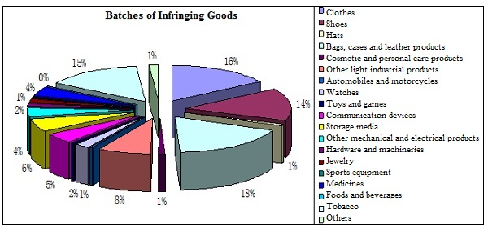

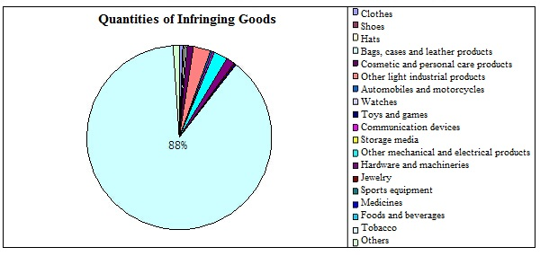

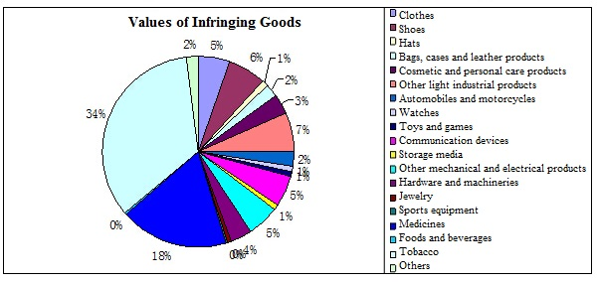

7) Most of the infringing goods are seized by the Customs through enforcement Ex Officio
In accordance with the Regulations of the People's Republic of China on the Customs Protection of Intellectual Property Rights, China Customs has the authority to implement IPR enforcement measures in the following three modes: (a) Seize the suspected infringing goods according to the request of the IPR holders; (b) For the goods which are not applied for detainment by the IPR holders in advance but the Customs believe that the goods are suspected of infringing the IPRs recorded with the General Administration of Customs, the Customs may detain the goods through the enforcement Ex Officio and confiscate the goods after determining that the goods are infringing goods; (c) For the infringing goods which are beyond the "reasonable quantity for personal usage" carried by passengers or delivered by post, the Customs may confiscate such goods.

In 2007, China Customs proactively strengthened the supervision on the import and export goods and enhanced the inspection on the entry and exit of infringing goods and articles. The achievements are as follows: All customs houses implemented the IPR protection measures Ex Officio, and the quantity of infringing goods cases proactively seized by the Customs in the luggage and postal channels accounted for 99% of the total cases. However, the quantity of cases in which the IPR holders applied for detainment of infringing goods accounted for no more than 1% of the total cases (see Table 13).

Table 13 Statistics on the Modes of Law enforcement by China Customs in 2007

Mode of Law Enforcement | Batch | Percentage | Quantity of Infringing Goods | Percentage | Value of Goods | Percentage
Protection Ex Officio | 1,068 | 14% | 324,222,080 | 97% | 366,977,536 | 84%
Protection on Request | 68 | 0.9% | 3,891,192 | 1% | 15,380,330 | 3%
Luggage and Postal Cases | 6,331 | 85% | 5,384,977 | 2% | 56,497,700 | 13%
Unit of batch: batch; Unit of infringing goods quantity: PCS/Pair; Unit of goods value: RMB

(6) Recognition of all Circles of the Society on the Achievements of China Customs IPR Enforcement

1) High appraisal of the society on China Customs IPR enforcement
- The Quality Brands Protection Committee of China Association of Enterprises with Foreign Investment (CAEFI QBPC), which was established by nearly 200 multinational corporations investing in China, awarded China Customs as the "Most Efficient Law Enforcement Authority" for three consecutive years.
- In May 2007, the World Customs Organization awarded the "Award of Outstanding Contribution to IPR Protection" to China Customs.
- From October 11 to 14, 2007, the Education, Science, Culture and Public Health Committee of the National People's Congress conducted a special investigation and research on the Customs IPR enforcement, solicited the reporting on the IPR enforcement work of the General Administration of Customs, visited Tianjin Customs and Qingdao Customs to inspect their IRP enforcement, and gave a high appraisal on the Customs IPR enforcement.

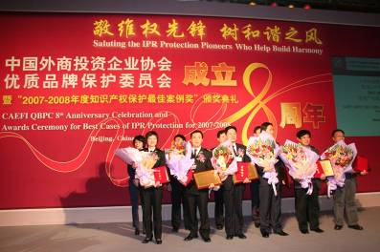
The IPR enforcement cases of Ningbo Customs and Huangpu Customs are ranked as the "Top 10 Cases in 2007-2008" by the QBPC

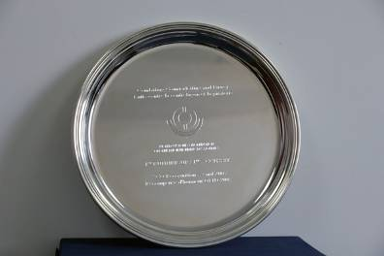
The World Customs Organization awarded the "Award of Outstanding Contribution to the IPR Protection" to China Customs

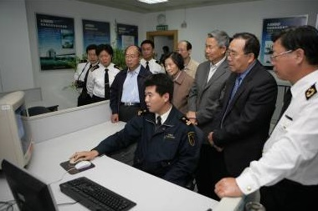
The members of the Standing Committee of the National People's Congress visited Qingdao Customs

2) Rapid increase of IPR recordation applications with the General Administration of Customs
The achievements made by China Customs in IPR enforcement attracted more and more IPR holders to apply for protection from the Customs. Therefore, the quantity of IPR recordation applications with the General Administration of Customs increased rapidly. According to the statistics, the General Administration of Customs received 2,788 items of IPR recordation applications in 2007, which increased by 48.3% as compared with 1,880 items of applications in 2006.

As of December 31, 2007, there were totally 9,325 items of IPRs recorded with the General Administration of Customs, among which 5,450 items were trademark rights, 3,494 items were patent rights, and 381 items were copyrights (see Table 14).

Table 14 Statistics on the types of recorded IPRs (as of December 31, 2007)

Trademark Right | Patent Right |  |  | Copyright
Trademark Right | Invention | Utility Model | Appearance Design | Copyright
5450 | 218 | 678 | 2598 | 381
Unit: item
The IPR holders whose IPRs are recorded with the General Administration of Customs are mainly the enterprises or persons from the countries and regions such as China, the USA, Japan, Taiwan of China, France, Hong Kong of China, Germany, Switzerland, Italy, the UK, the Netherlands, etc. (see Table 15).
Table 15 Statistics on the origins of recorded IPRs (as of December 31, 2007)
Country (Region) | Recorded IPRs | Percentage
China | 4896 | 52.5%
USA | 1636 | 17.5%
Japan | 457 | 4.9%
Taiwan of China | 325 | 3.5%
France | 319 | 3.4%
Hong Kong of China | 310 | 3.3%
Germany | 272 | 2.9%
Switzerland | 189 | 2.0%
Italy | 167 | 1.8%
United Kingdom | 139 | 1.5%
The Netherlands | 123 | 1.3%
Others | 492 | 5.3%
Unit of recorded IPRs: item
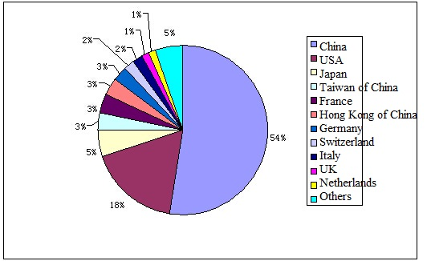
2. Challenges Currently Faced by China Customs in IPR Enforcement

In 2007, China Customs has made fruitful achievements in IPR enforcement. However, we must be aware that the IPR infringing activities in export and import sectors are still rampant, and the situation of Customs IPR enforcement is still not optimistic. During IPR enforcement, China Customs still face the following challenges:

(1) More Pressures on China Customs IPR Enforcement Due to Rapid Increase of Import & Export Volumes
In recent years, China's import and export trade has developed rapidly. In 2007, the total import & export value of China was USD 2,173.8 billion, the import & export volumes supervised by China Customs exceeded 2.4 billion tons, and the quantity of import & export sheets for customs declaration examined by China Customs exceeded 49 million pieces. To ensure that the import & export goods can go through customs clearance in time, the customs houses of many coastal ports of China have started the "Round-the-clock" customs clearance for 24 hours a day and 7 days a week. To meet the requirements of rapidly increasing supervision workload, China Customs cannot improve the seizure ratio of infringing goods only by increasing the goods inspection percentage, and must adopt the risk analysis method to improve the percentage and accuracy of seizing the infringing goods.

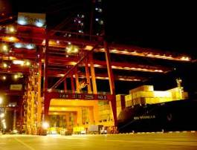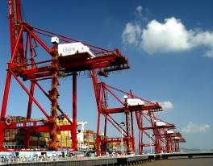
Loading and unloading of import and export goods in Ningbo Port day and night

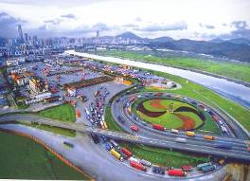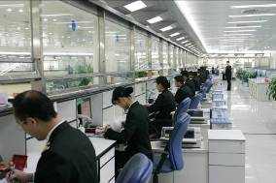
Shanghai Customs: the workload on the examination of customs declaration forms exceeds 1000 sheets per person each day
Shenzhen Customs: the inspection and release time for each truck travelling between Guangdong Province and Hong Kong is not more than 20 seconds

(2) More Diversified Infringing Methods Adopted by Lawbreakers
As China Customs continue to strengthen the crackdown on infringing goods in export and import sectors, the lawbreakers adopt more diversified infringing methods to evade the supervision and crackdown by China Customs. The infringing methods, which become more concealing, include the following:

1) Reporting a fake name for the goods
As there were many categories of import and export goods for customs declaration, the lawbreakers reported the goods under severe Customs supervision as common goods, so that it was difficult for the Customs to take corresponding supervision measures.

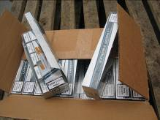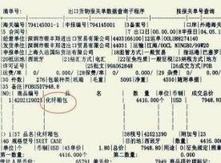
The counterfeit cigarettes are reported as "chemical fiber cases"

2) Not reporting the goods
The lawbreakers mixed the infringing goods with other legal goods, or hide the infringing goods in the legal goods, so that it was difficult for the Customs officers to find out the infringing goods.

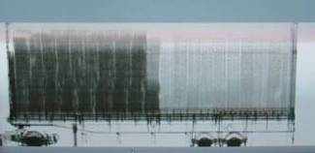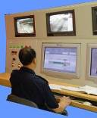
The Customs officers used H986 container inspection device to find out the counterfeit sports shoes hidden in a container (shaded area)

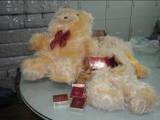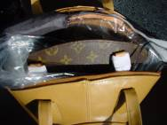
The Customs officers found out the counterfeit cigarettes hidden in animal toys and a famous brand bag sealed in the inner layer of a common bag

3) Covering the infringing trademarks
The lawbreakers used other trademarks, even some legally registered trademarks to cover the infringing trademarks. This infringing method was more concealing compared with other infringing methods.

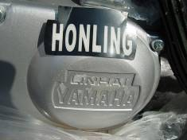
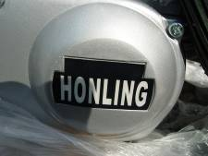
The lawbreakers used the tape with "HONLING" characters to cover the trademark "YAMAHA" on counterfeit motorcycle engines

4) Dividing the infringing goods into small consignments
The lawbreakers divided the infringing goods into parts or separated the goods from their trademarks, and then exported the goods in different cases or consignments to evade the supervision of China Customs.

5) Forging the authorization documents
The lawbreakers submitted forged IPR authorization documents to the Customs, in order to mislead the customs officers during customs clearance.

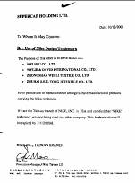
The lawbreakers forged the trademark authorization documents from Nike Company

7) Using similar trademarks
The lawbreakers used the forged trademarks on the infringing goods or the packages that are similar to the legitimate trademarks, so as to cause misidentification of the trademarks, or used the legitimate trademarks already registered by other people to apply for appearance design patent, so as to cause difficulties for Customs in trademark identification.

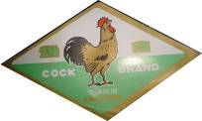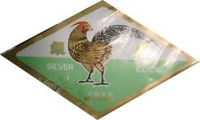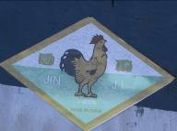
The lawbreakers used the infringing trademarks similar to the registered trademarks (the figure at the top)

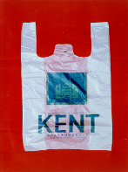
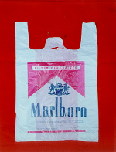

The lawbreakers used the legitimate cigarette trademark of others to apply for appearance design patent

(3) Ineffective Cooperation Provided by Some IPR Holders to the Law Enforcement of China Customs

During the Customs IPR enforcement, the IPR holders shall proactively implement their obligations according to the provisions of relevant laws. However, in actual practice, some IPR holders have weak awareness of law and insufficient experiences to safeguard their rights and interests. Therefore, they cannot fully understand Customs IPR enforcement, and have not provided necessary cooperation and support to the Customs officers. Some IPR holders even refuse to implement their legal obligations, for example, they fail to provide infringing information to the Customs in time, or fail to record their IPR authorization information with the Customs in time, or fail to respond to the rights confirmation notice sent by the Customs in time. In this way, their behaviours affected the smooth implementation of Customs IPR enforcement.

(4) Weak Awareness of IPR Protection of Import and Export Enterprises

In China, intellectual property right is still a new term for the public, and the average people know little about IPRs, let alone the awareness to create, respect and protect IPRs. Some import and export enterprises have no in-depth knowledge about the IPRs relating to some goods during international trade. Therefore, the following problems occur: (a) The innovative ability of some enterprises is low, the exported products are lack of technological contents, and the competitiveness of their own brands is weak. In order to survive in the market, these enterprises can only use the technologies or brands of other enterprises. Therefore, the Customs supervision workload is increased. (b) Some enterprises unintentionally committed infringement, especially the OEM enterprises. Due to lack of IPR awareness, when signing OEM contracts, these enterprises have not confirmed whether their clients own the IPRs relating to the products to be processed. Therefore, these enterprises may commit IPR infringement unconsciously.
3. Major Tasks for China Customs IPR Enforcement in 2008

(1) Adopt the Risk Analysis Method to Seize Infringing Goods

We will organize all customs houses across China to conduct the research on the implementation of risk analysis and surveillance, and actively promote the utilization of advanced supervision technologies like risk analysis technique in Customs IPR enforcement. In addition, we will reasonably distribute law enforcement resources, enhance the target-oriented inspections, and effectively improve the infringing goods seizure ratio under the condition that the goods inspection percentage cannot be increased sharply at present. Based on the Customs IPR Enforcement System, we will realize the information sharing of the IPR cases among all customs houses across China.

(2) Continue to Improve the Law Enforcement Basis for China Customs IPR Protection

We will summarize the Customs IPR enforcement experiences, amend the Measures for Implementing the Regulations on the Customs Protection of Intellectual Property Rights based on the new conditions and new features of IPR infringement relating to export and import goods, solve law enforcement problems, and further standardize Customs IPR enforcement actions. We will use the Customs announcements to clarify the standards which identify the reasonable quantity of self-used articles in the luggage and postal channels, so as to prevent lawbreakers from utilizing the exemption of the Customs on reasonable quantity of self-used articles and importing or exporting infringing goods in small quantities but for many times.

(3) Strengthen China Customs IPR Enforcement in Major Areas and Major Sectors
Based on the enhancement of crackdown on the import and export of infringing goods, we will continue to strengthen the supervision on the production and export of infringing goods in the areas where the IPR infringement is relatively more serious. In addition, we will strengthen the supervision on major sectors (like processing trade), major channels (like postal and express channels) and major air routes (like the air routes to Europe, USA and Japan), and continue the severe crackdown on the export and import of infringing goods.

(4) Enhance the Protection to the Independent IPRs of Domestic Enterprises
We will make a research and investigation on the independent IPRs of domestic enterprises and provide services for their innovations. In addition, we will know about the difficulties and problems for IPR protection of these enterprises and guide them to set up IPR protection organizations and help them to improve their IPR safeguarding abilities. Through the investigation and handling of IPR infringing cases, we will safeguard international reputation of the brands owned by domestic enterprises, and help the enterprises to enhance the international competitiveness of their products, so as to stimulate the implementation of the national strategy on the export of famous brand products.

(5) Strengthen the Trainings for On-site Customs Inspectors
We will invite the IPR holders and IPR experts to hold specialized trainings on the identification of infringing goods for on-site Customs inspectors, appropriately increase the quantity of trainings for Customs personnel of inland ports, and improve the abilities of Customs inspectors to seize infirming goods. To ensure the training results and effectively utilize the information resources, the General Administration of Customs will also edit the loose-leaf Infringing Goods Identification Manual that can be updated regularly, and dispatch the manual to each customs house.

(6) Actively Conduct the Publicity for China Customs IPR Enforcement
We will fully utilize various resources and adopt different means to make publicity for the law system of Customs IPR enforcement and the measures and achievements of China Customs in IPR enforcement, so as to improve the awareness of the public on Customs IPR enforcement. In addition, we will conduct regular activities like on-site promotion and symposiums to describe Customs IPR enforcement to the enterprises, especial to those enterprises involved in processing trade, so as to improve their awareness on IPR protection.

Conclusion

The year 2008 is the Olympic year, and successfully hosting the Olympic Games is the common aspiration of all people around the world. To create a favourable environment outside the Olympic Stadium and encourage fair competitions, China Customs will provide high-quality and convenient customs clearance services to the incoming and outgoing passengers during the period of Olympic Games, enhance the Customs IPR enforcement, and reduce the import and export of counterfeit goods and pirated goods. In order to provide cooperation to China Customs for IPR protection and jointly crack down on the illegal actions of IPR infringement and piracy, we call on all foreign friends who come to visit China do not purchase, carry or send by post infringing goods into or out of China.

