China Customs Enforcement of Intellectual Property Rights (IPR) in 2010

General Administration of Customs of the People’s Republic of China (GACC)

Contents

Foreword

1. Overview of the Law Enforcement on Intellectual Property Rights by China Customs in 2010
2. Particulars of the Infringing Goods Detained by China Customs in 2010
3. Main Measures for the Protection of Intellectual Property Rights by China Customs in 2010
4. Major Tasks for the Protection of Intellectual Property Rights by China Customs in 2011

Appendix: Statistics of the Law Enforcement on Intellectual Property Rights by China Customs in 2010

Foreword

In the year 2010, China Customs continued trying to fulfill the goal of "making China an innovative country and accelerating the transformation of the pattern of economic development" set by the Central Committee of the Communist Party of China and the State Council. To meet the strategic requirements as specified in the Outline of the National Intellectual Property Strategy, China Customs, fully performing their functions, has further enhanced the protection for intellectual property rights (IPR) by improving their law enforcement ability and actively participating in the international cooperation. In addition, China Customs has strived to play an important role in the national protection system for intellectual property rights by effectively cracking down on the infringing activities at the borders and keeping a fair and standardized foreign trade order. China Customs’ hard work has produced positive results.

1. Overview of the Law Enforcement on Intellectual Property Rights by China Customs in 2010

In 2010, for the protection of intellectual property rights, China Customs suspended the release of about 23,000 consignments of import or export goods under suspicion of infringing upon intellectual property rights, among which, 21,000 consignments were detained. 1 Compared with the year of 2009, the two figures decrease by 65.75% and 67.98% respectively (see Table 1).

Table 1 Goods suspended and detained by China Customs in 2010
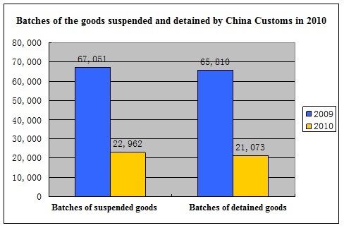

In 2010, China Customs detained 130 million PCS of infringing goods, with a total value of RMB 270 million. Compared with 2009, the quantity of infringing goods detained by China Customs decreases by about 140 million PCS or 52.3% in 2010, and the total value of infringing goods decreases by about 38.73% (see Table 2).

Table 2 Quantity and value of infringing goods detained by China Customs in 2010
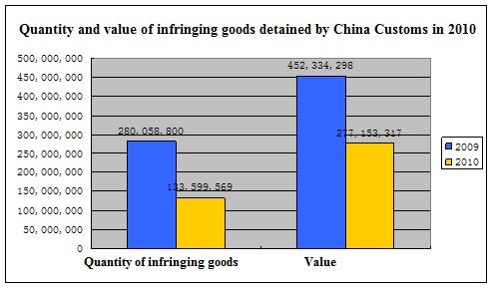

Compared with the year 2009, there are three main reasons for the decrease in consignments quantities and values of infringing goods detained by China Customs in 2010:

Firstly, in 2009, the Customs administrations throughout the country pooled efforts and mounted the "Special Operation for the Intellectual Property Rights Protection in the Postal and Express Mail Service", so that the quantities and values of infringing goods detained by China Customs increased substantially. 2 After the Special Operation, the quantities and values of detained goods returned to normal levels in 2010, which is still 89.2% higher than that in the year 2008. Excluding the influence of the Special Operation, the quantities of detained goods in 2010 continued to show a steady upward trend.

Secondly, among the infringing goods detained by China Customs, the quantity of cigarettes continued to decline sharply. According to the international general standards, the quantity of cigarettes is calculated in the unit of PCS. Therefore, the quantity of cigarettes which are regarded as infringing goods in a batch will exert a great influence on the total quantity of infringing goods. In 2010, the number of cases involving infringing tobacco detected by China Customs decreased somewhat; therefore, the quantity of detained infringing cigarettes decreased by over 100 million PCS compared with that in 2009, which caused substantial decrease in the total quantity of infringing goods seized in 2010. Therefore, the change in the structure of seized goods is also a main reason for the decline of the quantity of infringing goods detained by China Customs in 2010.

Thirdly, the sources of infringing goods are controlled. In 2010, all levels of law enforcement departments in China enhanced their control over the production and sales of fake products in China, and waged the "Special Campaign against IPR infringement and Production and Sales of Counterfeited and Forged Commodities". In this way, the production and sales of fake products in China have been effectively cracked down, and the law enforcement pressure of China Customs on imports and exports has been reduced to some extent. In addition, because of other reasons such as increase of domestic labor prices and enhancement of the combats on counterfeit products, some manufacturers of infringing products closed their factories in China, so that the quantity of infringing goods for export was in a declining trend.

2. Particulars of the Infringing Goods Detained by China Customs in 2010

(1) Goods seized in export sector still accounted for an absolute majority of seized goods

In 2010, the quantity of infringing goods seized in the export sector of China Customs was 130 million PCS (accounting for 99.86% of the total infringing goods) with a value of RMB 270 million (accounting for 98.38% of the total value) (see Table 3).

Table 3 Statistics of infringing goods seized at export and import of China Customs
Type | Quantity of Infringing Goods | Percentage | Value | Percentage
Import | 192,516 | 0.14% | 4,476,615 | 1.62%
Export | 133,407,053 | 99.86% | 272,676,702 | 98.38%
Unit of quantity of infringing goods: PCS/pair. Unit of value: RMB
The Chinese government has long been adhering to the philosophy of maintaining international trade order and protecting consumers' health and safety. The Agreement on Trade-related Aspects of Intellectual Property Rights (i.e., the TRIPS Agreement) 3 only provides that the contracting parties are required to bear their obligations for the protection of intellectual property rights in the import sector. However, the Chinese government has authorized the China Customs through legislation as early as 1995 to proactively implement the protection for intellectual property rights in both the import and export sectors. In this way, and made outstanding contribution to the protection of intellectual property rights and the safeguarding of international trade order.

(2) Goods infringing trademark rights still accounted for a majority of seized goods

In 2010, the infringing goods detained by China Customs were relating to different kinds of rights, including trademark rights, copyrights and related rights, patent rights, as well as the rights relating to Olympic and World Expo logos. However, the goods infringing trademark rights detained by China Customs still accounted for an absolute majority of the seized goods. Among the infringing goods detained by China Customs in 2010, the goods relating to trademark rights infringement accounted for 96.52% of the total goods in terms of quantity and for 94.02% in terms of value. In 2010, the percentage of goods relating to patents infringement detained by China Customs has increased slightly, from less than 1% in 2009 to 3.29% in 2010 in terms of quantity and from less than 1% in 2009 to 6.37% in 2010 in terms of value. (See Table 4)

Table 4 Statistics on the IPR types relating to infringing goods
IPR Types | Related Consignments | Quantity of Goods | Percentage | Value | Percentage
Trademark rights | 20,531 | 128,949,654 | 96.52% | 257,105,378 | 92.77%
Copyrights | 652 | 207,422 | 0.16% | 2,136,308 | 0.77%
Patents | 96 | 4,392,275 | 3.29% | 17,661,962 | 6.37%
Olympic and World Expo Logos | 22 | 50,218 | 0.04% | 249,668 | 0.09%
Unit of consignments: batch. Unit of commodities: PCS/pair. Unit of case value: RMB

(3) The category distribution of infringing goods remained basically the same as that in the previous year, while the quantity of cigarettes continued to decline sharply

Among the infringing goods detained by China Customs in 2010, the top 10 categories of goods in terms of quantity were still tobacco, cosmetic and personal care products, hardware and machinery, clothes, pharmaceuticals, automobiles and motorcycles and accessories, communication devices, shoes, bags and cases, and watches. The sequence of the category is consistent with that of 2009.

Among the infringing goods detained by China Customs in 2010, the quantity of detained infringing cigarettes has declined sharply. The China Customs detained a total of 75 million infringing cigarettes, decreasing by 58.15% or 105 million PCS compared with 180 million PCS in 2009. The percentage of detained cigarettes in the total quantity of detained goods has also declined from 65% in 2009 to 56.81% in 2010. The relevant law enforcement departments have strengthened their crackdown on the production and sales of infringing cigarettes in 2010, so that the export volume of infringing cigarettes has declined, and therefore the quantity of infringing cigarettes seized by China Customs has also declined (see Table 5).

Table 5 Statistics of the quantities and values of different infringing goods detained by China Customs in 2010
Category | Quantity | Percentage | Value | Percentage
Tobacco | 75,893,955 | 56.81% | 32,376,579 | 11.68%
Others | 22,881,974 | 17.13% | 29,732,142 | 10.73%
Other light industrial products | 5,514,473 | 4.13% | 19,320,571 | 6.97%
Cosmetic and care products | 5,119,547 | 3.83% | 12,150,499 | 4.38%
Hardware and machineries | 9,620,190 | 7.20% | 27,031,090 | 9.75%
Clothes | 1,785,583 | 1.34% | 28,030,030 | 10.11%
Pharmaceuticals | 2,040,274 | 1.53% | 1,227,812 | 0.44%
Other mechanical and electrical products | 4,938,573 | 3.70% | 28,430,847 | 10.26%
Automobiles and motorcycles | 614,304 | 0.46% | 6,366,606 | 2.30%
Communication devices | 657,257 | 0.49% | 27,766,510 | 10.02%
Shoes | 2,373,982 | 1.78% | 29,073,369 | 10.49%
Bags, cases and other leather products | 449,167 | 0.34% | 10,763,368 | 3.88%
Watches | 93,258 | 0.07% | 7,505,589 | 2.71%
Toys and games | 328,298 | 0.25% | 2,451,123 | 0.88%
Hats | 246,910 | 0.18% | 2,040,237 | 0.74%
Foods and beverages | 529,535 | 0.40% | 1,388,363 | 0.50%
Medical devices | 30,381 | 0.02% | 47,100 | 0.02%
Sports equipment | 215,349 | 0.16% | 6,783,520 | 2.45%
Storage media | 159,656 | 0.12% | 3,623,638 | 1.31%
Jewelry | 106,903 | 0.08% | 1,044,323 | 0.38%
Unit of commodities quantity: PCS/pair. Unit of value: RMB

(4) Maritime transport was still the main transport channel for infringing goods

In 2010, China Customs detained 1,880 consignments of infringing goods (nearly 130 million PCS) in the shipping channel, accounting for about 94.85% of the total quantity of detained goods in 2010. In the postal and express channels, China Customs detained 9,830 and 7,656 consignments of infringing goods, accounting for 46.65% and 36.33% of the total consignments of detained goods respectively. Affected by the "Special Operation for the Protection of Intellectual Property Rights in the Postal and Express Channels" in 2009, the infringement cases in postal channel and express channel in 2010 have decreased by 77.95% and 58.08% respectively as compared with 2009, but have increased by 32% and 429% respectively as compared with 2008, which shows that the figures in 2010 are still in an upward trend (see Table 6).

(5) Infringing goods were mainly seized at several import and export ports

In 2010 infringing goods were seized in the import and export sectors at 33 customs districts directly under the General Administration of Customs (GACC) in China. In terms of the consignments of seized infringing goods, four customs districts, namely Shenzhen Customs, Guangzhou Customs, Hangzhou Customs and Shanghai Customs, seized nearly 17,000 consignments of infringing goods, accounting for about 80% of the total consignments seized by the customs houses in China (see Table 7).

In terms of the quantities of seized infringing goods, the import and export of infringing goods were mainly concentrated in the main seaports such as Shenzhen, Ningbo, Huangpu, Xiamen, Shanghai, and Hangzhou. In 2010, the infringing goods seized by the above-mentioned six customs houses accounted for 90% of the total infringing goods seized by China Customs (see Table 8).

Table 6 Modes of transport for infringing goods (in terms of detained consignments)

Mode of Transport | Postal | Express | Maritime | Air | Road | Railway | Others
Consignments | 9,830 | 7,656 | 1,880 | 468 | 442 | 81 | 716
Percentage | 46.65% | 36.33% | 8.92% | 2.22% | 2.10% | 0.38% | 3.40%
Increase or decrease | -77.95% | -58.08% | 26.17% | 48.10% | -11.78% | -45.64% | 40.94%
Unit of batch: batch. Others: carried by passengers, bonded area, bonded warehouse, and etc.

Table 7 Consignments of infringing goods detained by port customs in 2010
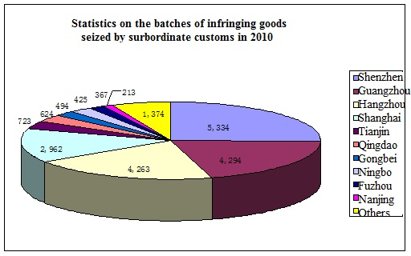
Statistics on the consignments of infringing goods seized by customs districts directly under the GACC in 2010

Table 8 Quantities of infringing goods detained by port customs in 2010
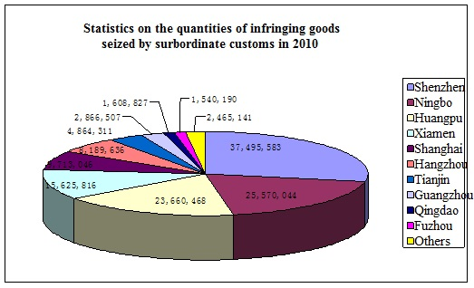
Statistics on the quantities of infringing goods seized by customs districts directly under the GACC in 2010

(6) Infringing goods were mostly related to IPRs of enterprises in the USA and Europe, while the percentage of infringing goods related to the IPRs of Chinese enterprises has increased significantly

In 2010, the IPR holders relating to the IPRs protected by China Customs were mainly from 33 countries and regions, and the quantity of IPRs protected by China Customs was 8408 items. 4 The IPR holders involved in relatively more IPR cases were from the USA, France, Germany, Japan, Finland, China 5, Italy, Switzerland, the UK, and the Netherlands (see Table 9). In terms of the quantity of IPR-related infringing goods, the IPRs from Switzerland, China, the UK, the USA, and Japan were infringed more frequently.
It is worth noting that, although the quantity of infringement of the IPRs of Chinese enterprises ranked No.6, the percentage of infringing goods relating to Chinese IPRs reached nearly 19%, ranking No.2 only after Switzerland and increased sharply from 7% in 2009. The value of infringing goods relating to Chinese IPRs also accounted for 15.5% of the total value of infringing goods, which ranked next to the USA only. In addition, as the infringing goods relating to Chinese IPRs were found in many fields including production, daily life, stationary, foods, medicines, vehicles, fittings and accessories, and etc.. In fact, the Chinese enterprises are most benefited from the IPR protection conducted by China Customs.

Table 9 Sources of protected IPRs
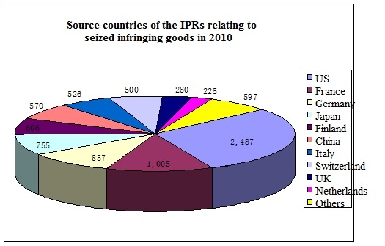

3. Main Measures for the Protection of Intellectual Property Rights by China Customs in 2010

(1) Give full play to the regulatory functions of Customs for the entry and exit of goods, and actively investigate the illegal actions relating to infringement
In 2010, China Customs continued to implements its supervisory functions for entry and exit of goods, and proactively investigated the illegal actions relating to infringement. The TRIPS Agreement only requires the contracting parties to suspend the release of infringing goods as per the request of IPR holders. However, China Customs proactively protected the IPRs with the authorization of relevant laws and their capacity, effectively curbed the cross-border circulation of infringing goods. In addition, China Customs continued to strengthen the inspection on major goods such as foods, medicines, and auto parts that impact the health and safety of the people, so that more people could directly benefit from the law enforcement of China Customs on IPR protection.


Tianjin Customs seized 1.96 million pills under suspicion of infringing the trademarks of Pfizer
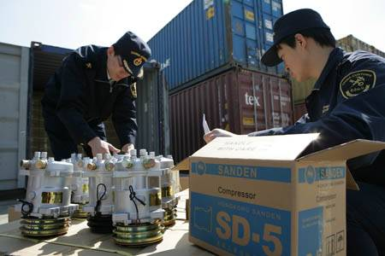
Tianjin Customs seized 2,200 automobile air conditioning compressors under suspicion of infringement

(2) Continue to improve the Customs laws and systems relating to IPR protection

In the year 2010, China Customs continued to improve the laws and systems related to Customs protection of IPRs, and assisted the Legislative Affairs Office of the State Council in completing the amendment of the Regulations of the People's Republic of China on Customs Protection of Intellectual Property Rights (hereinafter referred to as the "Regulations"). The revised Regulations were approved by the executive meeting of the State Council on March 17, 2010 and came into force as of April 1, 2010. In light of the decision of the State Council, the General Administration of Customs started the amendment of the Implementing Measures for the Regulations on Customs Protection of Intellectual Property Rights.
In addition, China Customs has updated and transformed the "Application System for Recordation of IPR Customs Protection". Under the principle of "facilitating people's application, management and query via the system", China Customs upgraded the system and conducted three trainings for the IPR holders, which received many praises from the IPR holders.

(3) Organize and implement the "Special Operation of China Customs on the Protection of Intellectual Property Rights in the 2010 World Expo"

During the preparation and convening of the 2010 World Expo in Shanghai, the General Administration of Customs and seven other agencies including the State Intellectual Property Office jointly issued the Circular on the Implementation of the Special Operation on the Protection of Intellectual Property Rights in the 2010 World Expo. To meet the requirements of aforesaid notice, all the customs houses in China strengthened their leadership and made good organization of their activities to implement the protection of IPRs relating to the World Expo. The General Administration of Customs issued a total of five announcements to approve the Customs protection over 58 items of IPR recordation concerning the World Expo, and required all customs houses to conduct trainings and public promotion to the on-site customs personnel and relevant import and export enterprises based on the recorded information and relevant laws and regulations. As the customs house in the host city of the World Expo, Shanghai Customs established a Leading Team for IPR Protection Concerning the World Expo and formulated the "Action Plan of the Working Groups for Security and IPR Protection Concerning the World Expo" and the "Special Action Plan of Shanghai Customs on the IPR Protection Concerning the World Expo". Shanghai Customs and three other customs houses in the Yangtze River Delta Area (i.e. Nanjing Customs, Hangzhou Customs and Ningbo Customs) jointly signed the Work Plan of the Customs in the Yangtze River Delta Area for Implementing the Special Operation for the IPR Protection Concerning the 2010 World Expo. With Shanghai Customs at the core, a multi-dimensional network was built to crack down on the illegal behaviors infringing the IPRs related to the World Expo in the Yangtze River Delta.
During the Special Operation, the customs houses in China have seized different goods infringing the World Expo IPRs through maritime shipping, air transport, inspection of passengers, postal, border trade and other transport channels. The goods included toothbrushes, tea, bracelets, coins, lighters, carpets, T-shirts, children's clothing, calendars, and car rear mirror. As at the end of 2010, China customs has intercepted more than 30 consignments of goods under suspicion of infringing the IPRs of Shanghai World Expo. The quantity of related goods reached 106,000 PCS, with a total value of more than RMB 630,000. The Special Operation has effectively cracked down on the illegal activities which infringed on the IPRs of the World Expo.
The Special Operations for World Expo IPR protection conducted by the China Customs system obtained highly appraisal from relevant departments. 31 groups and 67 individuals were awarded the titles of Excellent Group or Individual due to their contributions to the special operation for the protection of World Expo IPRs.

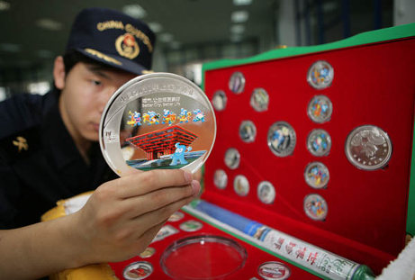
Tianjin Customs seized "World Expo Commemorative Coins"
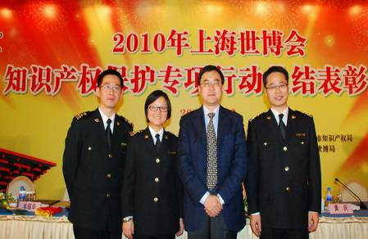
Award ceremony for the Special Operation of IPR protection for the 2010 World Expo

(4) Organize and implement the "Nationwide Special Campaign of China Customs against IPR Infringements and Production and Sales of Counterfeited and Forged Commodities"

According to the State Council's decision and deployment, the General Administration of Customs has organized and carried out the "Special Campaign of China Customs against IPR Infringements and Production and Sales of Counterfeited and Forged Commodities" (hereinafter called the "Special Campaign") as from October 2010. To ensure that the special operation would achieve fruitful results, the General Administration of Customs formulated, according to the practice of customs enforcement, an Implementation Plan for Major Tasks of the Special Campaign against IPR Infringements and Production and Sales of Counterfeited and Forged Commodities, which specified three major tasks in the Special Campaign: (i) taking the southeastern coastal areas with much domestic and foreign concern as the major region under monitoring; (ii) taking the mode of shipment and mail usually adopted for export of infringing goods as the major channels under monitoring; and (iii) taking the fake medicines, foods and auto parts which endanger consumers' health and safety as the major commodities under monitoring, and meanwhile, increasing the inspection proportion export goods with the risks of infringement.
As of December 31, 2010, the customs houses in China have seized over 2,000 consignments of infringing goods during the Special Campaign. The quantity of infringing goods reached 38.36 million PCS, with a total value of RMB 120 million. The major seized goods included clothes, shoes and hats, auto parts, cigarettes, medicines, small appliances, daily chemical products, hardware and machineries.

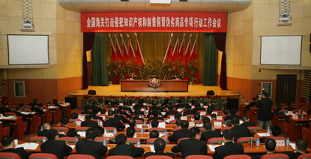
Work meeting of the China Customs on the Special Campaign against IPR Infringements and Production and Sales of Counterfeited and Forged Commodities

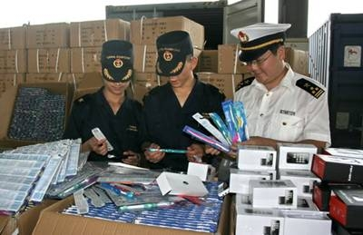
Xiamen Customs seized over 500,000 infringing goods during the Special Campaign
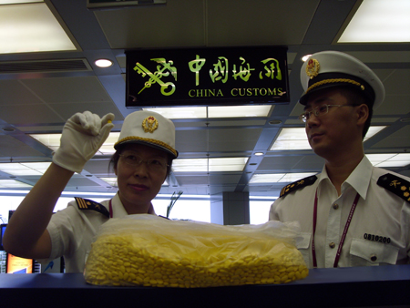
Shenyang Customs seized about 16,000 pills infringing the IPR of the Cialis brand at the exit channel for passengers

(5) Further strengthen the protection for the IPRs of domestic enterprises

Strengthening the protection of intellectual property rights of domestic enterprises is always the focus of customs enforcement. In 2010, the customs houses in China detained about 25 million PCS of goods infringing 570 IPRs of domestic enterprises, accounting for 18.67% of the total quantity of detained goods. The value of the infringing goods stood at about RMB 43 million.
Taking into consideration of the local industrial features, the customs houses in China enhanced their inspection efforts to strengthen the protection on the IPRs of domestic enterprises. China Customs held many symposiums to discuss on the protection of domestic IPRs, and inviting customs experts, heads of industrial associations, and enterprise representatives to describe the customs protection on IPRs, share their experience in cooperating with customs houses in the IPR protection, and demonstrate their achievements in the protection of domestic IPRs in recent years. During the inspection, Tianjin Customs focused on the protection of domestic brands and products susceptible to infringements, and strengthened their efforts during the inspection of goods. The Customs handled a series of typical infringement cases including 10,780 fake axes in the brand "Diamond", 2.5 tons of galvanized iron wires in the brand of "Golden Cup", 1,048 cases of preserved vegetables in the brand of "TTS", and 2,400 pairs of sports shoes in the brand of "Anta". Xinjiang Shanshan Huaxing Casting Co., Ltd. is the largest radiators exporter in Northwest China. Its products are sold well in Central Asia and its annual output value exceeds RMB 1 million. However, the counterfeit products in the markets have made the company suffer severe losses. Therefore, Urumqi Customs has integrated the information sources from the enterprise and the market, proactively shared the information on infringement with the IPR holders, provided support during the case clues acceptance and preservation before litigation. The Customs seized 9,800 counterfeit radiators (with a total value of RMB 357,000) that infringed on the patent rights of the company in October 2010. In this way, the Customs has provided impetus for the future development and innovation of the media- and small-sized enterprise with their own IPRs.

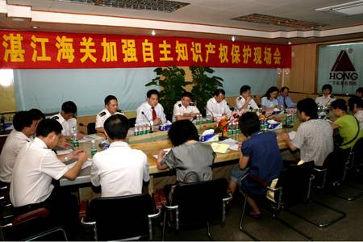
Zhanjiang Customs held an onsite work meeting to strengthen the IPRs protection

(6) Continuously explore the cooperation models with other law enforcement authorities

China Customs is fully aware that the effective crackdown on infringement of IPRs is inseparable from the cooperation with other law enforcement agencies in China. Therefore, China Customs strives to form a unified force for IPR protection by continuously exploring the effective cooperation models. To further strengthen the convergence and cooperation between the administrative law enforcement by the customs and the criminal law enforcement by the police, China Customs has proactively implemented the cooperation with local police offices in accordance with the Provisional Regulations on Strengthening the Law Enforcement Cooperation Relating to Intellectual Property Rights, and carried out their cooperation with the local public security authorities. For the cases under suspicion of IPR infringement found during the customs supervision, the customs personnel will report and transfer the cases to the public security authorities in accordance with the relevant provisions, so that the latter can promptly file the cases and begin relevant investigation.
In 2010, with the instruction of the risk control, Qingdao Customs seized a batch of goods under suspicion of infringing the "Nike and hook drawing" registered with the General Administration of Customs, and reported the clues of this case to the public security authority. Based on the clues, the public security authority made in-depth investigation, and captured all the six suspects (including three foreigners) involving in production, sales and customs declaration for export concerning fake "Nike" products. In this way, the public security authority successfully cracked down on an illegal organization committing transnational infringement, and seized a large amount of fake "Nike" products, four printing plates to print fake "Nike" logo, and a set of production equipment including computers. In this case, the customs house effectively destroyed the source of infringing actions, enhanced the Customs' deterrence over infringing actions, and established a typical model for the cooperation between the customs house and the public security authority.

(7) Deepen the cooperation between China Customs and IPR holders

In recent years, China Customs has continued to strengthen strategic partnership with IPR holders, and established the corresponding cooperation mechanisms in multiple fields including legislation research & discussion, law enforcement training, and information reporting. At present, the General Administration of Customs has signed a Memorandum of Understanding with many IPR holders (such as Motion Picture Association of America and CAEFI Quality Brands Protection Committee) to strengthen their cooperation in IPR protection. In 2010, the General Administration of Customs organized several seminars with IPR holders to collect the opinions of different enterprises on the work of China Customs. In order to improve the IPRs law enforcement ability of on-site customs officers, the customs houses proactively invited IPR holders to go to the site of customs supervision and held trainings on identification of infringing goods. In March 2010, the General Administration of Customs held a dialogue with enterprises on the IPR protection. More than 130 Chinese and foreign enterprises from the CAEFI Quality Brands Protection Committee, International Trademark Association and other associations attended the meeting, on which the General Administration of Customs made a report on the achievements of IPR customs protection in 2009 and described the work plan of IPR customs protection in 2010.

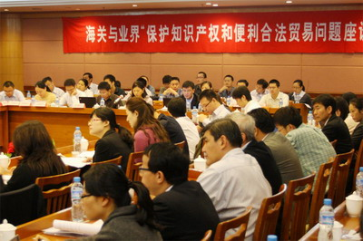
China Customs held a Symposium with the Industrial Circles on IPR Protection and Convenient and Legal Trade in Wuxi City

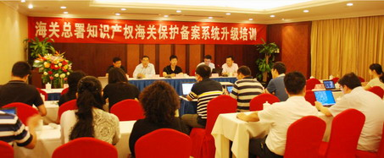
China Customs opened a training class in Guiyang City on the upgraded IPR recordation system to introduce and demonstrate the relevant application for the enterprises present

(8) Further expand the cooperation in IPR law enforcement with the customs of other countries

Through the IPR dialogue mechanism and IPR cooperation frame between the Chinese government and the governments of the USA, Europe, Switzerland, Russia, Japan and South Korea, and Brazil, China Customs and the customs of the aforesaid countries have continued to conduct bilateral and multilateral cooperation on the IPR law enforcement, enhanced the communication and collaboration during international IPR law enforcement, so as to eliminate misunderstandings and enhance mutual trust, and create a highly efficient international IPR protection network between the customs of different countries. As of 2010, the Chinese government has signed bilateral administrative mutual-aid agreements with more than 30 countries and regions in the world, and all these agreements covered the contents relating to the cooperation on IPR law enforcement. In 2010, the customs of China and Russia signed a Memorandum on Cooperation in Strengthening IPR Law Enforcement, the customs of China and Europe renewed the Action Plan Concerning Customs Cooperation On IPR, and the customs of China, Japan and South Korea jointly held the Global Congress/WCO Regional Forum on Protection of Intellectual Property Rights. In addition, the General Administration of Customs of China and Hong Kong Customs held the Seminar for the Cooperation of IPR Law Enforcement in the Mainland of China and Hong Kong Region, and made an in-depth discussion on the IPR cooperation between the both customs.

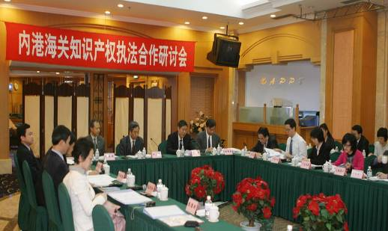
The Seminar for the Cooperation of IPR Law Enforcement in the Mainland of China and Hong Kong Region held in Xiamen March 2010

In addition, China Customs actively participated in the activities carried out by the WCO, WTO, WIPO, INTERPOL and other international organizations, and strived to play a more important role in the international IPR affairs.

(9) Actively carry out publicity and education activities relating to IPRs

In 2010, China Customs took the April 26 IPR Publicity Week as an opportunity to introduce the Customs protection for IPRs. In addition, they continued to select and announce "Top 10 Cases of IPR Customs Protection in China in 2009", and issued the Report on IPR Protection by China Customs in 2009. Moreover, China Customs strengthened the routine publicity and education targeting import and export enterprises, customs brokers, express delivery enterprises, inbound and outbound passengers, and enterprises engaging in processing trade to improve their knowledge about IPR protection. To achieve better publicity results, the General Administration of Customs provided "One-stop Service for IPR Customs Protection" on its web portal, and held online interviews about IPR customs protection for many times.


GACC officers discussed with netizens about IPR protection via the website of GACC

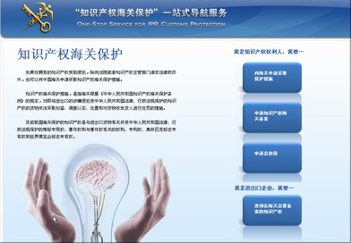
Homepage of the "One-stop Service for IPR Customs Protection"

According to the requirements of the General Administration of Customs, the customs houses in China proactively organized different forms of publicity and education activities about IPR protection for the public. China Customs focused on the cultivation of IPR protection awareness of domestic enterprises, especially of the enterprises engaging in processing fixed brands. When receiving orders, these enterprises need to inquire the customs houses about the IPR status relating to the orders, so as to avoid the infringement on IPRs due to lack of information. In addition, the customs houses explore a variety of channels to conduct the publicity of IPR protection for the public, so as to reduce the sources of IPR infringement.

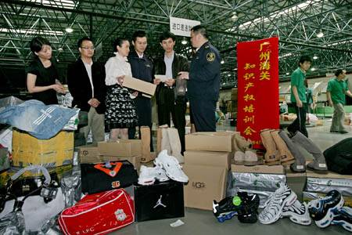
On-site IPR protection training of Guangzhou Customs

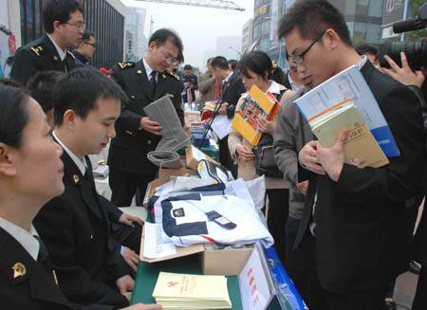
Chengdu Customs officers conducted a publicity activity for IPR protection on the pedestrian plaza on Hongxing Road

During the legal enforcement concerning IPR protection in 2010, China Customs has adhered to the guideline of "conducting administration by law, safeguarding national gateway, serving the economy and promoting the development", and continuously improved law enforcement measures to enhance the ability of law enforcement, so as to realize the "legal and convenient trade" and "effectively crack down on infringement activities". The IPR protection of China Customs has always received high recognition from domestic and overseas organizations and relevant IPR holders. In March 2010, the Quality Brands Protection Committee of China Association of Enterprises with Foreign Investment (QBPC) awarded the title of "QBPC2000-2010 Excellent Unit with Contributions to China IPR Protection and Quality Supervision" to the Department of Policy and Legal Affairs of the General Administration of Customs, Ningbo Customs, Huangpu Customs, and Shenzhen Customs; the title of "QBPC2000-2010 Excellent Individual with Contributions to China IPR Protection and Quality Supervision" to two officers responsible for IPR protection with the General Administration of Customs; the title of "QBPC2009-2010 Top 10 Best Practices of IPR Protection in China" to the IPR cases detected by Shanghai Customs, Huangpu Customs, and Shenzhen Customs. The World Bearings Association commented for many times on international occasions that "China Customs has made outstanding contributions to the IPR protection". In October 2010, Nokia representatives paid a special visit to Xiamen Customs and expressed their gratitude to the Customs for their protection of IPRs of Nokia products, and presented the Customs a plaque with words "Safeguard the State's Gateway and Protect the Dignity of Law".

4. Major Tasks for the Protection of Intellectual Property Rights by China Customs in 2011

In 2011, China Customs will continue to implement the nationwide "Special Campaign against IPR Infringements and Production and Sales of Counterfeited and Forged Commodities" and consolidate the achievements. With the work goals of "consolidating the foundation, focusing on the implementation, and popularizing the achievements", all the customs houses will further push forward the IPR protection. The major tasks in 2011 are described below:

(1) Further strengthen the law enforcement and improve the legal system for IPR customs protection

China Customs will continue to implement the nationwide "Special Campaign against IPR Infringements and Production and Sales of Counterfeited and Forged Commodities ", and make research on the new trends and features of IPR protection during the period of the 12th Five Year Plan according to the targets and tasks specified in the Outline of the National Intellectual Property Strategy and based on the law enforcement experiences obtained from the previous stages of Special Campaign of China Customs, so as to further optimize the law system for IPR customs protection. In 2011, with the enforcement of the new Regulations of the People's Republic of China on Customs Protection of Intellectual Property Rights, the General Administration of Customs will complete the amendment to the Implementing Measures for the Regulations of the People's Republic of China on Customs Protection of Intellectual Property Rights.

(2) Promote the protection of intellectual property rights of domestic enterprises

China Customs will strengthen the cooperation with relevant industry associations and chambers of commerce, carry out a survey on the protection of the IPRs of domestic enterprises, learn the difficulties and problems faced by domestic enterprises in respect of the protection of their IPRs, take specific measures to help domestic enterprises improve their ability of IPR protection, and stimulate the innovations and application of independent IPRs of domestic enterprises.

(3) Develop and apply the "IPR Customs Protection System" to raise the information level of IPR customs protection

In 2011, China Customs will integrate the two databases: IPRs Customs Protection Recordation System and IPR Customs Protection Law Enforcement System, and develop a unified platform named "IPR Customs Protection System", which supports new functions such as IPR holders' management of IPRs, query of infringement cases found by the customs, and providing information to the customs, so as to increase the interaction between the IPR holders and the customs by technological means, and improve the law enforcement efficiency and transparency of Customs.

(4) Continue to strengthen the publicity and promote the understanding of various circles of the society on IPR customs protection

To further publicize the IPR protection procedures and law enforcement efficiency, China Customs will guide all walks of life to concern, understand, support and utilize IPR customs protection through releasing the annual report on IPR customs protection, selecting Top 10 Best Practices of IPR customs protection each year, distributing the publicity documents on IPR customs protection and holding briefing sessions on IPR customs protection.

(5) Continue to promote the international cooperation in IPR customs protection
Within the framework of the cooperation agreement for IPR customs protection between China and Europe, the USA, Russia, Japan and South Korea, China Customs will continue to cooperate with major trade partners in exchanging legal system and enforcement experiences, the sharing of information and statistics on infringement case, and the collaboration in respect of law enforcement. In addition, China Customs will proactively participate in the IPR affairs organized by international organizations such as the World Customs Organization, World Trade Organization and World Intellectual Property Organization, so as to make contributions to the international IPR affairs, and continue to advance the cooperation in IPR law enforcement between the customs in the mainland of China and Hong Kong Customs and Macao Customs.

(6) Expand the scope and contents of trainings on IPR customs protection and build a team of experts for the IPR customs protection

China Custom will continue to improve the ability and level of IPR law enforcement, and form their own styles and features in respect of IPR law enforcement. By utilizing the training platform, China Customs will invite experts from the judicial, administrative and law enforcement authorities to give lectures on the judicial practice standards for identification of infringement facts and other relevant IPR knowledge, so as to expand the knowledge scope of the law enforcement personnel of Customs.

Appendix

Statistics of the Law Enforcement on Intellectual Property Rights by China Customs in 2010

Table 1 Statistics on the consignments of suspended and detained goods in 2010
Year | Consignments of Suspended Goods | Year-on-year Change | Consignments of Detained Goods | Year-on-year Change
2009 | 67,051 | 410.28%↑ | 65,810 | 491%↑
2010 | 22,962 | 65.75%↓ | 21,073 | 67.98%↓
Unit of suspended and detained infringing goods: batch

Table 2 Statistics on the infringing goods detained by China Customs in 2010
Year | Quantity of Infringing Goods | Year-on-year Change | Value | Year-on-year Change
2009 | 280,058,800 | 56.59%↓ | 452,334,298 | 53.43%↑
2010 | 133,599,569 | 52.30%↓ | 277,153,316 | 38.73%↓
Unit of the quantity of infringing goods: PCS/pair. Unit of value: RMB

Table 3 Statistics on the imported and exported infringing goods seized by China Customs in 2010
Type | Quantity of Infringing Goods | Percentage | Value | Percentage
Import | 192,516 | 0.14% | 4,476,615 | 1.62%
Export | 133,407,053 | 99.86% | 272,676,701 | 98.38%
Unit of the quantity of infringing goods: PCS/pair. Unit of value: RMB

Table 4 Statistics on the IPR types relating to infringing goods
IPR Type | Related Consignments | Quantity of Goods | Percentage | Value | Percentage
Trademark right | 20,531 | 128,949,654 | 96.52% | 257,105,378 | 92.77%
Copyright | 652 | 207,422 | 0.16% | 2,136,308 | 0.77%
Patent right | 96 | 4,392,275 | 3.29% | 17,661,961.99 | 6.37%
Olympic / World Expo Logos | 22 | 50218 | 0.04% | 249668 | 0.09%
Unit of consignments: batch. Unit of goods: PCS/Pair. Unit of value: RMB

Table 5 Statistics on the quantities and values of infringing goods detained by China Customs in 2010
Category of Goods | Quantity of Goods | Percentage | Value | Percentage
Tobacco | 75,893,955 | 56.81% | 32,376,579 | 11.68%
Others | 22,881,974 | 17.13% | 29,732,142 | 10.73%
Other light industrial products | 5,514,473 | 4.13% | 19,320,570 | 6.97%
Cosmetic products | 5,119,547 | 3.83% | 12,150,499 | 4.38%
hardware and machineries | 9,620,190 | 7.2% | 2,703,109 | 9.75%
Clothes | 1,785,583 | 1.34% | 28,030,029 | 10.11%
Medicines | 2,040,274 | 1.53% | 1,227,811 | 0.44%
Other mechanical and electrical products | 4,938,573 | 3.7% | 28,430,846 | 10.26%
Automobiles and motorcycles | 614,304 | 0.46% | 6,366,606 | 2.3%
Communication devices | 657,257 | 0.49% | 27,766,510 | 10.02%
Shoes | 2,373,982 | 1.78% | 29,073,369 | 10.49%
Bags, cases and leather products | 449,167 | 0.34% | 10,763,368 | 3.88%
Watches | 93,258 | 0.07% | 7,505,589 | 2.71%
Toys and games | 328,298 | 0.25% | 2,451,122 | 0.88%
Hats | 246,910 | 0.18% | 2,040,237 | 0.74%
Foods and beverages | 529,535 | 0.4% | 1,388,363 | 0.5%
Medical machineries | 30,381 | 0.02% | 47,100 | 0.02%
Sports equipment | 215,349 | 0.16% | 6,783,520 | 2.45%
Storage media | 159,656 | 0.12% | 3,623,638 | 1.31%
Jewelry | 106,903 | 0.08% | 1,044,322 | 0.38%
Unit of goods quantity: PCS/Pair. Unit of value: RMB
Table 6 Statistics on the categories of infringing goods detained by China Customs in 2010 and 2009
 | Quantity of Goods |  |  | Value of Goods
Category of Goods | 2010 | 2009 | Year-on-year Change | 2010 | 2009 | Year-on-year Change
Clothes | 1,785,583 | 4,986,126 | -64.19% | 28,030,029 | 31,237,653 | -10%
Shoes | 2,373,982 | 1,184,250 | 100.46% | 29,073,369 | 25,807,920 | 13%
Hats | 246,910 | 282,262 | -12.52% | 2,040,237 | 1,959,904 | 4%
Bags, cases and leather products | 449,167 | 418,746 | 7.26% | 10,763,368 | 10,757,195 | 0%
cosmetic products | 5,119,547 | 10,996,937 | -53.45% | 12,150,499 | 30,503,080 | -60%
Other light industrial products | 5,514,473 | 15,918,160 | -65.36% | 19,320,570 | 44,083,239 | -56%
Automobiles and motorcycles | 614,304 | 1,580,608 | -61.13% | 6,366,606 | 8,555,921 | -26%
Watches | 93,258 | 319,770 | -70.84% | 7,505,589 | 42,909,738 | -83%
Toys and games | 328,298 | 313,311 | 4.78% | 2,451,122 | 2,893,802 | -15%
Communication devices | 657,257 | 1,469,595 | -55.28% | 27,766,510 | 57,628,798 | -52%
Storage media | 159,656 | 95,735 | 66.77% | 3,623,638 | 7,894,969 | -54%
Other mechanical and electrical products | 4,938,573 | 1,747,306 | 182.64% | 28,430,846 | 21,765,950 | 31%
hardware and machineries | 9,620,190 | 8,712,423 | 10.42% | 27,031,090 | 10,226,569 | 164%
Jewelry | 106,903 | 39,165 | 172.96% | 1,044,322 | 4,101,115 | -75%
Sports equipment | 215,349 | 130,893 | 64.52% | 6,783,520 | 793,251 | 755%
Medical machineries | 30,381 | 198,744 | -84.71% | 47,100 | 199,920 | -76%
Medicines | 2,040,274 | 3,344,790 | -39% | 1,227,811 | 48,379,124 | -97%
Foods and beverages | 529,535 | 212,533 | 149.15% | 1,388,363 | 846,142 | 64%
tobacco | 75,893,955 | 181,346,116 | -58.15% | 32,376,579 | 57,874,722 | -44%
Others | 22,881,974 | 46,761,330 | -51.07% | 29,732,142 | 43,915,284.67 | -32%
Unit of goods quantity: PCS/Pair. Unit of value: RMB

Table 7 Modes of transport of infringing goods (in terms of detained consignments)
Mode of Transport | Postal | Express | Maritime | Air | Road | Railway | Others
Consignments | 9830 | 7656 | 1880 | 468 | 442 | 81 | 716
Percentage | 46.65 | 36.33% | 8.92% | 2.22% | 2.10% | 0.38% | 3.40%
Year-on-year Change | -77.95% | -58.08% | 26.17% | 48.10% | -11.78% | -45.64% | 40.94%
Unit of consignments: batch. Others: carried by passengers, bonded zone, bonded warehouse, and etc.

Table 8 Modes of transport of infringing goods (in terms of quantity of the goods)
Mode of Transport | Postal | Express | Maritime | Air | Road | Railway | Others
Quantity of Goods | 1,006,033 | 3,393,374 | 126,712,852 | 549,058 | 925,443 | 469,371 | 543,438
Percentage | 0.75% | 2.54% | 94.85% | 0.41% | 0.69% | 0.35% | 0.41%
Year-on-year Change | -62.61% | 238.01% | -53.72% | 299.25% | -55.53% | 225.13% | 149.67%
Unit of goods quantity: PCS/Pair. Others: carried by passengers, bonded zone, bonded warehouse, and etc.

Table 9 Modes of transport of infringing goods (in terms of value of the goods)
Mode of Transport | Postal | Express | Maritime | Air | Road | Railway | Others
Value | 33,329,956 | 11,911,102 | 200,480,392 | 16,203,973 | 8,869,112 | 1,648,603 | 4,710,179
Percentage | 12.03% | 4.30% | 72.34% | 5.85% | 3.20% | 0.59% | 1.70%
Year-on-year Change | -63.49% | -29.05% | -30.75% | -55.94% | -29.66% | -24.76% | 49.16%
Unit of goods value: RMB. Others: carried by passengers, bonded zone, bonded warehouse, and etc.

Table 10 Statistics on the infringing goods detained by customs districts directly under GACC
Customs District Directly under GACC | Batch | Goods Quantity | Value
Shenzhen Customs | 5,334 | 37,495,583 | 33,009,506
Guangzhou Customs | 4,294 | 2,866,507 | 8,714,881
Hangzhou Customs | 4,263 | 8,189,636 | 31,901,940
Shanghai Customs | 2,962 | 9,713,046 | 29,746,215
Tianjin Customs | 723 | 4,864,311 | 13,636,155
Qingdao Customs | 624 | 1,608,827 | 8,699,835
Gongbei Customs | 494 | 308,619 | 6,115,298
Ningbo Customs | 425 | 25,570,044 | 54,116,721
Fuzhou Customs | 367 | 1,540,190 | 4,116,980
Nanjing Customs | 213 | 386,690 | 3,061,392
Wuhan Customs | 167 | 9,762 | 662,460
Beijing Customs | 157 | 305,158 | 36,274,280
Shenyang Customs | 156 | 6,394 | 233,540
Harbin Customs | 140 | 9,949 | 1,007,239
Kunming Customs | 109 | 710,293 | 1,795,592
Huangpu Customs | 108 | 23,660,468 | 16,828,894
Xiamen Customs | 103 | 15,625,816 | 18,661,111
Xi’an Customs | 84 | 221 | 38,800
Lhasa Customs | 65 | 25,253 | 435,251
Urumqi Customs | 59 | 39,209 | 2,021,830
Dalian Customs | 58 | 65,929 | 2,072,873
Nanning Customs | 43 | 317,633 | 504,144
Chongqing Customs | 42 | 8,171 | 1,191,840
Manzhouli Customs | 29 | 641 | 45,647
Jiangmen Customs | 18 | 177,290 | 1,140,455
Hohhot Customs | 9 | 4,045 | 118,120
Changchun Customs | 9 | 66,421 | 234,051
Zhengzhou Customs | 6 | 8,632 | 486,209
Changsha Customs | 6 | 692 | 138,720
Taiyuan Customs | 2 | 72 | 35,500
Shantou Customs | 2 | 13,044 | 78,700
Haikou Customs | 1 | 5 | 2,000
Chengdu Customs | 1 | 1,018 | 27,130
Unit of consignments: batch. Unit of goods: PCS/Pair. Unit of value: RMB

Table 11 Statistics on the destination countries/regions of infringing goods
Destination Countries/Regions | Consignments | Quantity of Goods | Value
USA | 7,222 | 15,944,116 | 22,834,567
Germany | 2,731 | 453,940 | 6,437,878
United Kingdom | 1,861 | 2,676,999 | 5,358,477
Japan | 1,631 | 178,741 | 4,518,804
France | 988 | 9,873,519 | 7,017,696
Australia | 694 | 240,225 | 4,038,419
Hong Kong of China | 605 | 506,006 | 6,428,074
Canada | 483 | 60,350 | 1,575,766
South Korea | 430 | 133,481 | 3,556,290
Russian Federation | 425 | 717,342 | 6,433,569
Spain | 405 | 9,648,773 | 4,656,712
Poland | 390 | 24,526 | 522,548
Macao of China | 379 | 31,562 | 2,808,666
The Netherlands | 193 | 20,359 | 719,894
Brazil | 165 | 195,788 | 28,430,583
Iran | 107 | 1,177,428 | 10,604,352
United Arab Emirates | 104 | 6,293,996 | 15,168,699
Taiwan of China | 89 | 9,467 | 1,005,817
India | 87 | 4,792,695 | 8,691,020
Malaysia | 85 | 12,544,301 | 9,253,158
Bulgaria | 82 | 581 | 3,951
Italy | 80 | 132,054 | 1,634,723
Argentina | 79 | 578,113 | 2,782,911
Vietnam | 75 | 689,399 | 3,076,811
Greece | 73 | 6,212,876 | 6,166,953
Sweden | 69 | 3,255 | 76,781
Nepal | 65 | 25,253 | 435,251
Pakistan | 57 | 971,631 | 7,033,496
New Zealand | 54 | 38,828 | 193,822
Grenada | 46 | 46 | 2,300
Peru | 46 | 68,367 | 237,998
Nigeria | 44 | 744,859 | 7,555,913
South Africa | 42 | 456,581 | 1,730,624
Kazakhstan | 40 | 32,835 | 1,364,490
Turkey | 40 | 53,415 | 1,253,519
Singapore | 40 | 18,537,171 | 6,663,985
Kenya | 38 | 927,855 | 3,618,995
Ukraine | 37 | 1,033,330 | 1,930,167
Indonesia | 36 | 4,809,455 | 2,163,619
Saudi Arabia | 35 | 882,313 | 2,719,266
Egypt | 34 | 451,178 | 2,920,703
Morocco | 32 | 1,256,178 | 4,091,141
Ireland | 29 | 14,844 | 549,133
Ghana | 28 | 1,597,220 | 1,599,998
Myanmar | 28 | 679,291 | 1,355,944
Djibouti | 26 | 420,694 | 2,308,297
Czech Republic | 26 | 44,665 | 475,812
Philippines | 25 | 268,213 | 1,068,708
Israel | 24 | 233,700 | 907,549
Algeria | 23 | 161,398 | 1,842,442
China | 22 | 23,077 | 232,411
Iraq | 21 | 636,515 | 1,888,992
Chile | 20 | 142,174 | 1,992,772
Thailand | 19 | 302,213 | 2,054,285
Romania | 18 | 368,027 | 611,964
Tanzania | 17 | 2,534,898 | 1,185,348
Venezuela | 16 | 1,387,299 | 1,556,564
Jordan | 16 | 137,451 | 874,372
Togo | 15 | 2,863,110 | 3,830,221
Bangladesh | 15 | 230,370 | 1,815,101
Norway | 15 | 2,815 | 113,050
Sudan | 15 | 1,061,277 | 2,043,590
Angola | 14 | 201,449 | 920,104
Papua New Guinea | 14 | 35,386 | 441,146
Benin | 14 | 2,583,239 | 3,595,973
Belgium | 14 | 100,924 | 982,045
Croatia | 14 | 26,520 | 1,144,217
Columbia | 13 | 167,052 | 1,875,210
Zimbabwe | 13 | 1,124,587 | 2,080,365
Senegal | 13 | 218,245 | 1,129,261
Tunisia | 13 | 145,921 | 874,878
North Korea | 11 | 67,091 | 531,398
Mongolia | 11 | 3,256 | 114,940
Guatemala | 11 | 138,747 | 1,162,214
Republic of Yemen | 11 | 1,824,042 | 1,086,081
Panama | 10 | 117,299 | 1,404,540
Lebanon | 10 | 80,551 | 442,180
Libya | 10 | 36,036 | 1,374,290
Sri Lanka | 10 | 932,119 | 674,199
Finland | 9 | 68,129 | 551,577
Cambodia | 9 | 1,767 | 311,737
Kirgizstan | 8 | 11,576 | 508,000
Cameroon | 8 | 898,001 | 365,679
Laos | 8 | 798 | 154,718
Mozambique | 8 | 223,774 | 458,205
Namibia | 8 | 72,702 | 569,263
Kuwait | 7 | 52,125 | 264,254
Syria | 7 | 120,805 | 466,270
Ethiopia | 6 | 735,858 | 1,032,374
Mauritania | 6 | 26,766 | 331,660
Switzerland | 6 | 1,391 | 54,865
Uruguay | 6 | 258,183 | 598,662
Albania | 5 | 14,768 | 365,682
Republic of Guinea | 5 | 675,587 | 740,390
Ivory Coast | 5 | 2,016,080 | 2,009,536
Mexico | 5 | 42,709 | 626,345
Serbia | 5 | 12,061 | 99,800
Turkmenistan | 5 | 47,280 | 4,717,330
East Timor | 4 | 2,970 | 68,400
Congo | 4 | 9,232 | 43,600
Lithuania | 4 | 21,685 | 70,150
Madagascar | 4 | 28,324 | 164,145
Portugal | 4 | 915 | 7,640
Salvador | 4 | 29,034 | 112,074
Oman | 3 | 11,662 | 196,960
Azerbaijan | 3 | 524 | 136,230
Puerto Rico | 3 | 27,428 | 601,102
Dominica | 3 | 6,837 | 95,212
Fiji | 3 | 5,708 | 152,960
Costa Rica | 3 | 56,748 | 216,205
Georgia | 3 | 11,560 | 174,100
Latvia | 3 | 37,204 | 1,457,013
Malawi | 3 | 8,292 | 103,834
Cyprus | 3 | 5,934 | 51,170
Uganda | 3 | 16,044 | 153,786
Hungary | 3 | 3,532 | 16,640
Jamaica | 3 | 9,969 | 142,885
Austria | 2 | 664 | 547,775
Paraguay | 2 | 61,195 | 160,378
Bahrain | 2 | 64 | 23,200
Belize | 2 | 26,348 | 330,080
Denmark | 2 | 619 | 17,750
Cape Verde | 2 | 4,487 | 61,270
Guyana | 2 | 150 | 26,000
Mauritius | 2 | 179,488 | 132,761
Democratic Republic of the Congo | 2 | 191,300 | 142,975
Nicaragua | 2 | 9,936 | 84,760
Niger | 2 | 4,192 | 38,400
Samoa | 2 | 17,433 | 178,740
Uzbekistan | 2 | 385,976 | 16,009
Afghanistan | 1 | 120 | 7,200
Estonia | 1 | 308 | 21,640
Palestine | 1 | 11 | 1,100
Botswana | 1 | 43,140 | 86,200
Equatorial Guinea | 1 | 600 | 6,000
Ecuador | 1 | 318,120 | 591,603
Honduras | 1 | 24,960 | 110,000
Gabon | 1 | 116 | 11,600
Qatar | 1 | 2,409,600 | 361,440
Liberia | 1 | 10 | 500
Maldives | 1 | 16 | 4,800
Mali | 1 | 430 | 1,000
Republic of Palau | 1 | 31 | 310
Sierra Leone | 1 | 400 | 40,000
Saint Lucia | 1 | 50 | 3,405
Slovenia | 1 | 600 | 30,000
Suriname | 1 | 2,996 | 42,366
Tajikistan | 1 | 45 | 9,000
Trinidad and Tobago | 1 | 1,300 | 16,600
Unit of consignments: batch. Unit of goods: PCS/Pair. Unit of value: RMB

Table 12 Source countries/regions of IPRs
Country / Region | Item of rights | Quantity of Goods | Value
USA | 2,487 | 16,207,730 | 59,901,829
France | 1,005 | 4,562,043 | 11,744,980
Germany | 857 | 3,050,617 | 25,516,360
Japan | 755 | 15,082,842 | 29,439,960
Finland | 606 | 624,499 | 22,951,991
China | 570 | 24,942,948 | 42,970,527
Italy | 526 | 527,547 | 13,444,488
Switzerland | 500 | 30,976,454 | 22,700,306
United Kingdom | 280 | 23,947,842 | 14,284,942
Netherland | 225 | 3,692,654 | 11,561,031
Luxemburg | 187 | 186,867 | 2,598,664
Sweden | 121 | 317,257 | 3,186,464
South Korea | 113 | 216,449 | 3,703,746
Canada | 41 | 382,467 | 3,789,284
Hong Kong of China | 32 | 516,075 | 3,639,005
Australia | 25 | 104,302 | 881,225
Taiwan of China | 20 | 6,086,848 | 1,877,333
British Virgin Islands | 9 | 13,838 | 213,950
Brazil | 7 | 93,240 | 378,928
Spain | 7 | 137,878 | 677,858
Singapore | 7 | 1,055,354 | 631,871
United Arab Emirates | 5 | 184,052 | 476,386
India | 5 | 406,464 | 119,280
Thailand | 4 | 139,920 | 271,376
Denmark | 3 | 15 | 974
Hungary | 3 | 93,200 | 81,600
Turkey | 2 | 3,240 | 34,800
British Mann Islands | 2 | 245 | 34,000
Belgium | 1 | 30,000 | 27,500
Czech Republic | 1 | 12,936 | 1,294
Liechtenstein | 1 | 10 | 1,000
Norway | 1 | 2,304 | 3,110
Unit of goods quantity: PCS/Pair. Unit of value: RMB

Table 13 Modes of Law enforcement on infringing goods seized by China Customs in 2010
Mode of Law Enforcement | Consignments | Percentage | Quantity of Goods | Percentage | Value | Percentage
According to application | 113 | 0.54% | 4,805,332 | 3.6% | 21,523,364 | 7.77%
According to recordation | 1599 | 7.59% | 123,830,799 | 92.69% | 190,498,644 | 68.73%
Luggage and postal cases | 19363 | 91.89% | 4,963,438 | 3.72% | 65,131,308,51 | 23.50%
Unit of consignments: batch. Unit of goods quantity: PCS/Pair. Unit of value: RMB

1 According to the Regulations of the People's Republic of China on the Customs Protection of Intellectual Property Rights, if the customs find out that the imported or exported goods are suspected of infringing the intellectual property rights registered with the General Administration of Customs, the customs may suspend the release of such goods and notify the IPR holders with a written notice. If the IPR holders request detaining the suspect infringing goods, they shall apply to the customs and provide relevant guarantee within three days upon receipt of the aforesaid written notice. If the IPR holders fail to apply for such detention or fail to provide the relevant guarantee, the customs shall release the aforesaid goods.
2 The goods transported through postal channel are featured by many consignments, small quantities and high values.
3. According to the provisions of Article 51 of the TRIPS, a contracting party shall establish a procedure which enables the IPR holder to submit a written application to the appropriate judicial or administrative authority and then the Customs suspend the release of the imported goods into free circulation. For the infringing goods to be exported from its territory, the contracting party may rather than must formulate the procedure for suspending release of such goods by the Customs.
4 Here, the "items" of IPRs refer to the times of the IPR-related infringing goods detained by China Customs.
5 . In this report, "China" does not include Hong Kong Region, Macao Region and Taiwan Region of China.

